Table 1: Physio-chemical properties of the soils

|  |  |  |  |
| --- | --- | --- | --- |
| Properties | Units | Sand | Rania Soil |
| pH | - | 6.42 | 8.6 |
| Particle Density | g cm-3 | 2.68 | 1.62 |
| Bulk Density | g cm-3 | 1.58 | 0.71 |
| Porosity | % | 41.04 | 56.17% |
| SOM | % | 0.076 | 2.01 |
| Sand | % | 100 | 25 |
| Silt | % | 0 | 70 |
| Clay | % | 0 | 5 |
| Soil Texture | - | Sand | Silty sand |

Table2: The kinetic model parameters and regression coefficients for Cr adsorption onto sand and soil

|  |  |  |  |  |  |  |  |  |  |  |  |  |  |  |
| --- | --- | --- | --- | --- | --- | --- | --- | --- | --- | --- | --- | --- | --- | --- |
| Soil | T (˚C) | WC | pH | Pseudo-first-order | | | Pseudo-second-order | | | Intra-particle Diffusion | | | Liquid Film Diffusion | |
|  |  |  |  | K1 (h-1) | Qe (mg g-1) | r2 | K2 (g mg-1 min-1) | Qe (mg g-1) | r2 | Ki (mg g h-1) | Ci (mg g-1) | r2 | K1 (h-1) | r2 |
| Sandy Soil | 25 | 0.6 | 4 | 0.442 | 1.070 | 0.989 | 0.548 | 1.197 | 0.982 | 0.223 | 0.286 | 0.808 | 0.389 | 0.895 |
| 7 | 0.472 | 0.984 | 0.994 | 0.644 | 1.094 | 0.983 | 0.204 | 0.271 | 0.789 | 0.495 | 0.985 |
| 11 | 0.495 | 0.860 | 0.991 | 0.812 | 0.951 | 0.976 | 0.175 | 0.252 | 0.766 | 0.397 | 0.925 |
| 0.8 | 4 | 0.407 | 1.161 | 0.988 | 0.427 | 1.318 | 0.968 | 0.247 | 0.286 | 0.780 | 0.431 | 0.786 |
| 7 | 0.503 | 0.877 | 0.992 | 0.829 | 0.966 | 0.974 | 0.178 | 0.257 | 0.745 | 0.569 | 0.987 |
| 11 | 0.442 | 0.818 | 0.994 | 0.714 | 0.915 | 0.915 | 0.172 | 0.213 | 0.785 | 0.576 | 0.963 |
| 1.0 | 4 | 0.412 | 0.844 | 0.991 | 0.625 | 0.951 | 0.987 | 0.181 | 0.205 | 0.826 | 0.344 | 0.988 |
| 7 | 0.507 | 0.672 | 0.992 | 1.084 | 0.740 | 0.977 | 0.137 | 0.197 | 0.754 | 0.453 | 0.947 |
| 11 | 0.439 | 0.587 | 0.989 | 0.958 | 0.66 | 0.967 | 0.l25 | 0.146 | 0.766 | 0.514 | 0.965 |
| 40 | 0.6 | 4 | 0.419 | 1.246 | 0.992 | 0.420 | 1.407 | 0.981 | 0.264 | 0.310 | 0.815 | 0.431 | 0.958 |
| 7 | 0.489 | 1.060 | 0.993 | 0.647 | 1.174 | 0.992 | 0.220 | 0.296 | 0.799 | 0.375 | 0.989 |
| 11 | 0.493 | 0.942 | 0.987 | 0.732 | 1.048 | 0.965 | 0.192 | 0.277 | 0.743 | 0.576 | 0.983 |
| 0.8 | 4 | 0.409 | 1.273 | 0.994 | 0.392 | 1.445 | 0.980 | 0.272 | 0.308 | 0.816 | 0.389 | 0.986 |
| 7 | 0.493 | 1.608 | 0.989 | 0.649 | 1.183 | 0.969 | 0.220 | 0.301 | 0.742 | 0.526 | 0.950 |
| 11 | 0.447 | 0.882 | 0.996 | 0.667 | 0.988 | 0.983 | 0.187 | 0.228 | 0.792 | 0.410 | 0.940 |
| 1.0 | 4 | 0.498 | 0.933 | 0.997 | 0.770 | 1.029 | 0.984 | 0.193 | 0.262 | 0.760 | 0.493 | 0.955 |
| 7 | 0.585 | 0.770 | 0.996 | 1.244 | 0.833 | 0.988 | 0.153 | 0.244 | 0.725 | 0.533 | 0.996 |
| 11 | 0.485 | 0.679 | 0.993 | 0.990 | 0.753 | 0.996 | 0.145 | 0.176 | 0.805 | 0.290 | 0.905 |
| Rania Soil | 25 | 0.6 | 4 | 0.350 | 10.213 | 0.992 | 0.039 | 11.786 | 0.985 | 2.257 | 2.075 | 0.861 | 0.431 | 0.928 |
| 7 | 0.372 | 9.670 | 0.993 | 0.044 | 11.091 | 0.980 | 2.118 | 2.082 | 0.833 | 0.454 | 0.968 |
| 11 | 0.400 | 7.381 | 0.997 | 0.066 | 8.387 | 0.983 | 1.598 | 1.707 | 0.819 | 0.456 | 0.985 |
| 0.8 | 4 | 0.422 | 9.479 | 0.994 | 0.056 | 10.689 | 0.974 | 2.019 | 2.337 | 0.788 | 0.672 | 0.947 |
| 7 | 0.428 | 8.138 | 0.993 | 0.069 | 9.128 | 0.986 | 1.733 | 2.031 | 0.808 | 0.616 | 0.885 |
| 11 | 0.291 | 7.299 | 0.993 | 0.038 | 8.736 | 0.979 | 1.660 | 1.145 | 0.885 | 0.347 | 0.985 |
| 1.0 | 4 | 0.333 | 7.120 | 0.991 | 0.051 | 8,294 | 0.979 | 1.578 | 1.386 | 0.864 | 0.642 | 0.720 |
| 7 | 0.368 | 6.228 | 0.983 | 0.071 | 7.119 | 0.984 | 1.359 | 1.362 | 0.860 | 0.452 | 0.826 |
| 11 | 0.303 | 5.218 | 0.960 | 0.062 | 6.118 | 0.961 | 1.155 | 0.960 | 0.885 | 0.445 | 0.944 |
| 40 | 0.6 | 4 | 0.338 | 11.682 | 0.983 | 0.033 | 13.507 | 0.989 | 2.609 | 2.251 | 0.881 | 0.510 | 0.857 |
| 7 | 0.230 | 11.057 | 0.991 | 0.028 | 13.028 | 0.994 | 2.522 | 1.784 | 0.918 | 0.249 | 0.980 |
| 11 | 0.322 | 9.127 | 0.988 | 0.038 | 10.683 | 0.989 | 2.067 | 1.610 | 0.892 | 0.388 | 0.843 |
| 0.8 | 4 | 0.346 | 11.556 | 0.982 | 0.035 | 10.319 | 0.985 | 2.570 | 2.292 | 0.874 | 0.386 | 0.935 |
| 7 | 0.381 | 10.435 | 0.991 | 0.044 | 11.887 | 0.993 | 2.298 | 2.254 | 0.859 | 0.401 | 0.966 |
| 11 | 0.270 | 10.076 | 0.995 | 0.025 | 12.189 | 0.992 | 2.336 | 1.334 | 0.924 | 0.373 | 0.837 |
| 1.0 | 4 | 0.284 | 9.929 | 0.997 | 0.027 | 11.928 | 0.988 | 2.288 | 1.428 | 0.904 | 0.390 | 0.967 |
| 7 | 0.308 | 8.985 | 0.988 | 0.035 | 10.633 | 0.987 | 2.057 | 1.453 | 0.900 | 0.366 | 0.896 |
| 11 | 0.348 | 6.910 | 0.991 | 0.055 | 8.035 | 0.982 | 1.541 | 1.356 | 0.860 | 0.295 | 0.940 |

Table 3: The isotherm Sorption model parameters and coefficient of regression for Cr onto sandy soil and Rania soil

|  |  |  |  |  |  |  |  |
| --- | --- | --- | --- | --- | --- | --- | --- |
| Soil Type | pH | Linner Isotherm | Langmuir Isotherm | Freundlich Isotherm | | | |
|  |  | Kd (L kg-1) | KL (mg g-1) | Kf (mg(1-1.nf) L1/nf g-1) | 1/nf | nf | r2 |
| Sandy Soil | 4 | 0.005 | 0.218 | 0.184 | 0.323 | 3.095 | 0.614 |
| 7 | 0.003 | 0.098 | 0.083 | 0.298 | 3.356 | 0.559 |
| 11 | 0.004 | 0.032 | 0.027 | 0.601 | 1.663 | 0.725 |
| Rania Soil | 4 | 0.088 | 0.043 | 0.306 | 0.664 | 1.506 | 0.866 |
| 7 | 0.108 | 0.015 | 0.198 | 0.829 | 1.206 | 0.922 |
| 11 | 0.047 | 0.007 | 0.108 | 0.786 | 1.272 | 0.933 |

Table 4: Thermodynamics parameters of the adsorption for Cr onto the sandy soil and Rania soil

|  |  |  |  |  |  |  |
| --- | --- | --- | --- | --- | --- | --- |
| Soil Type | ∆H˚ (kJ mol-1) | ∆S˚ (kJ mol-1K-1) | ∆G˚ (kJ mol-1) | | | |
|  |  |  | 298 | 308 | 318 | 328 |
| Sandy Soil | 27.159 | 0.0416 | 14.762 | 14.346 | 13.930 | 13.514 |
| Rania Soil | 4.541 | -0.0158 | 9.249 | 9.407 | 9.565 | 9.723 |

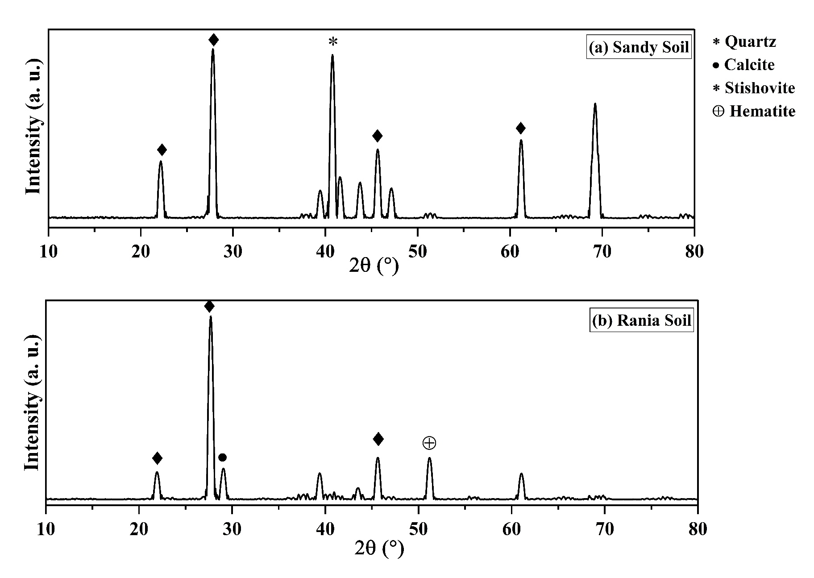

Figure 1: X-ray diffraction of (a) sandy soil and (b) Rania soil

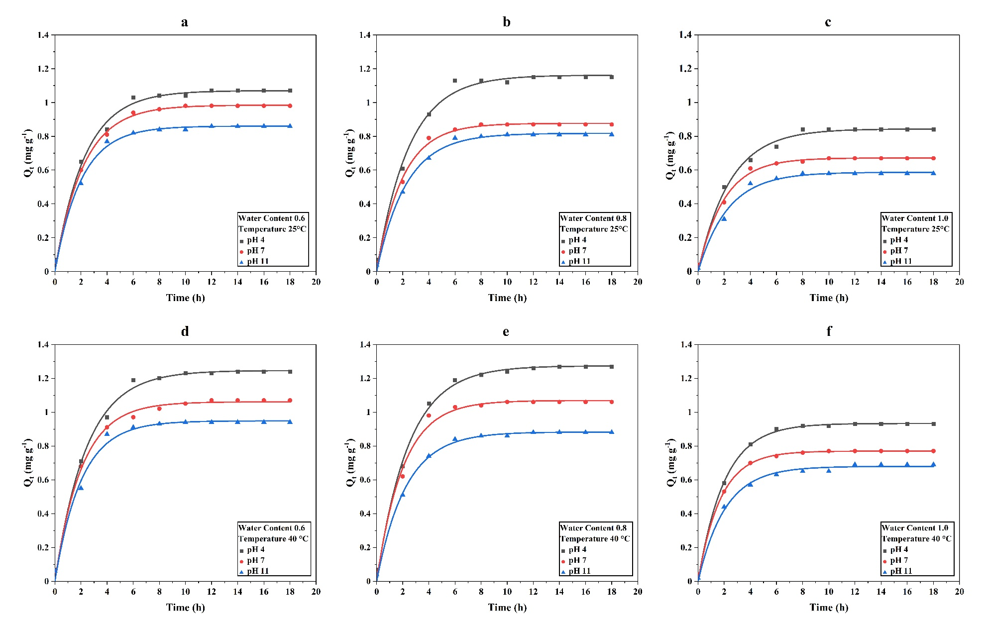

Figure 2: Pseudo first order kinetic curves for Cr into the sand

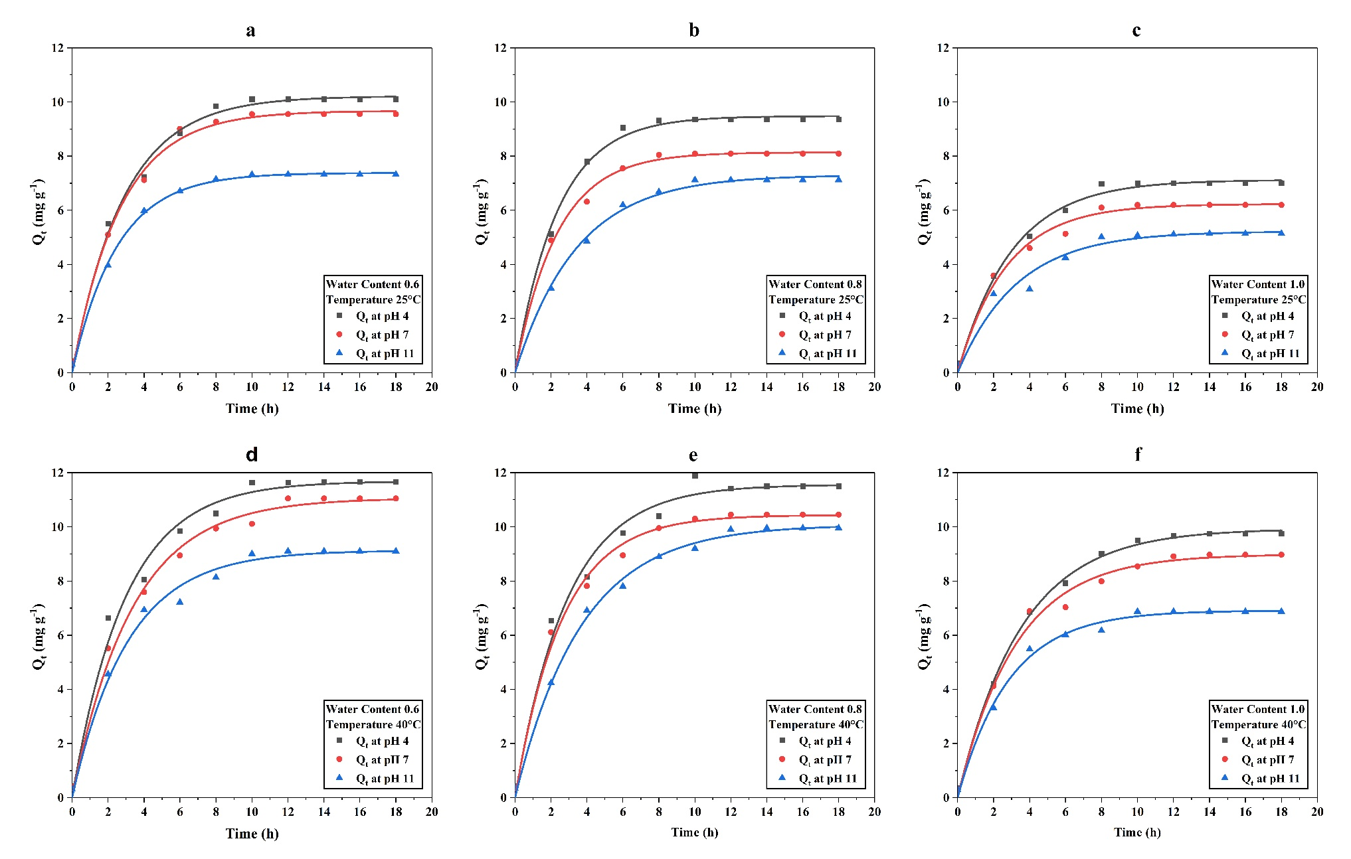

Figure 3: Pseudo First order curves for Cr into the Rania soil

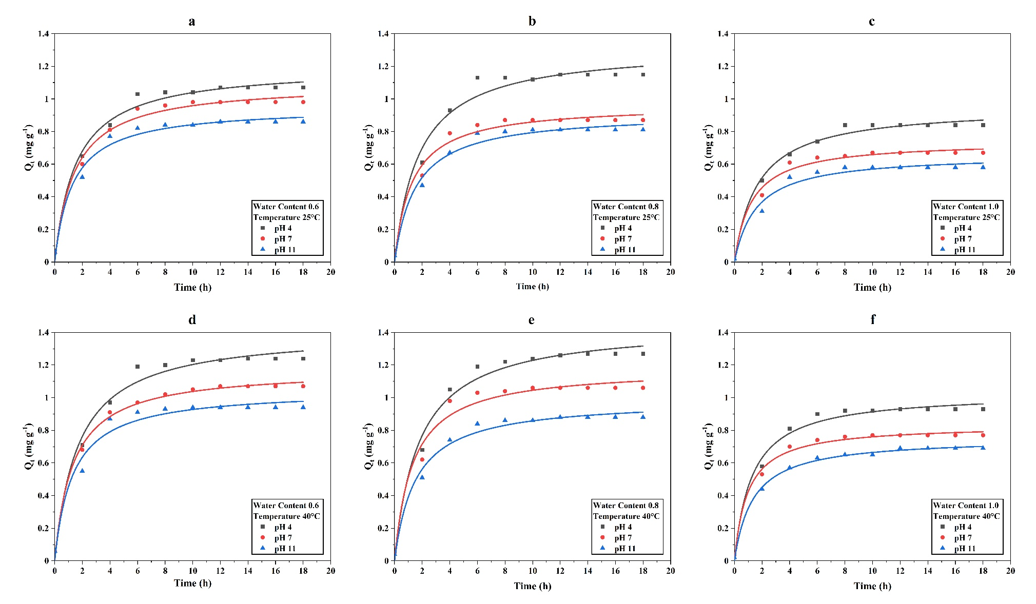

Figure 4: Pseudo second order kinetic curves for Cr into the sand

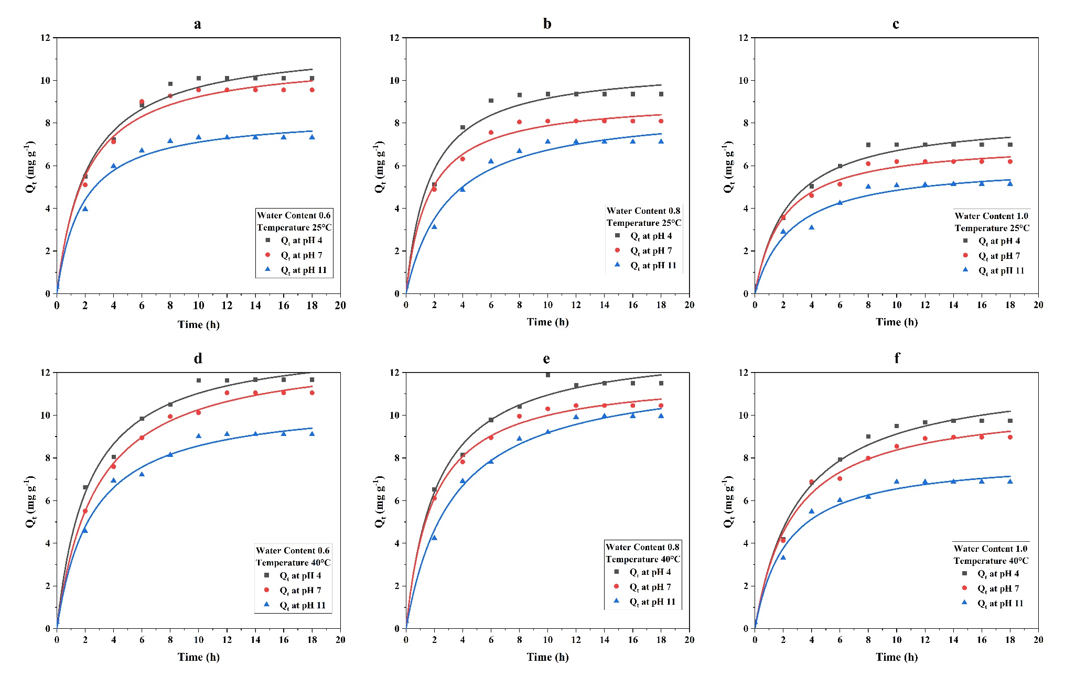

Figure 5: Pseudo Second order curves for Cr into the Rania soil

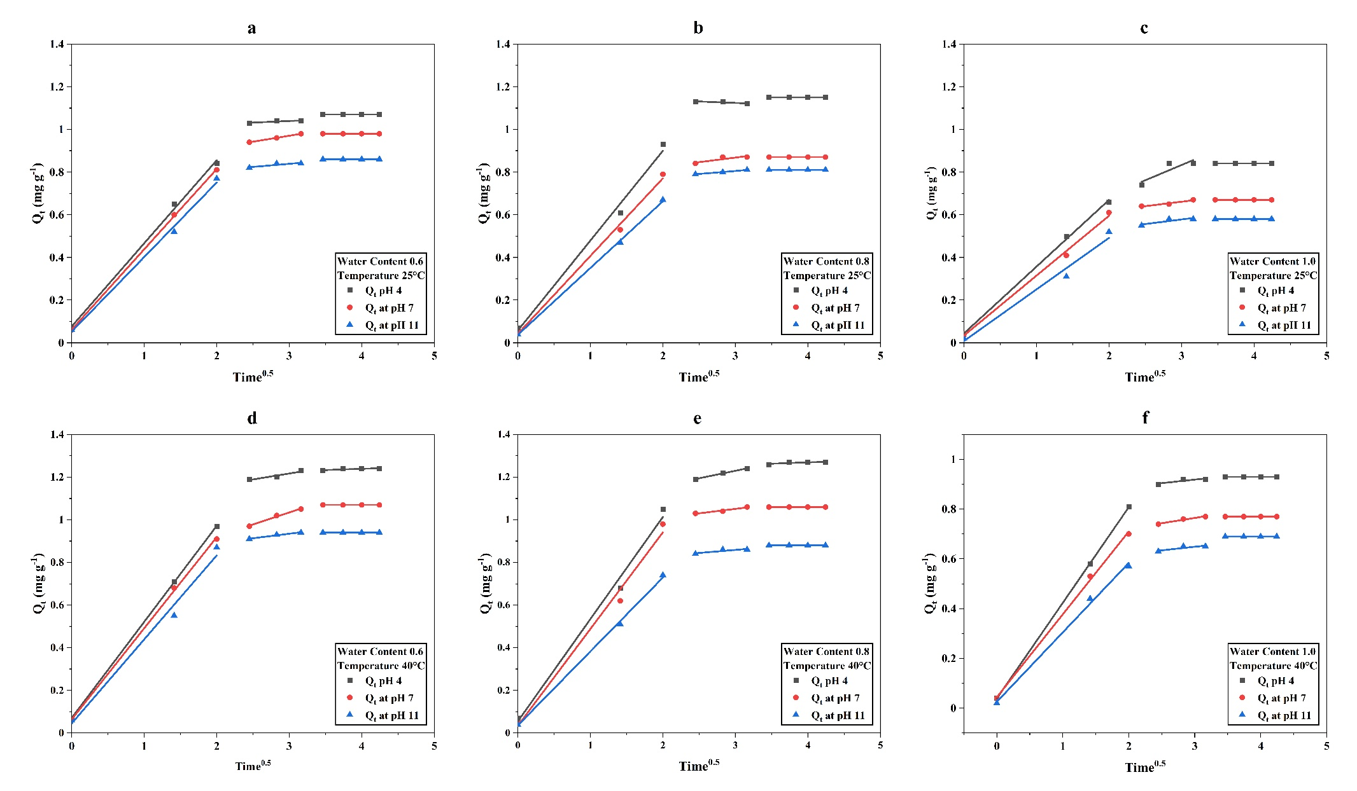

Figure 6: Intra particle diffusion curves for Cr into the sand

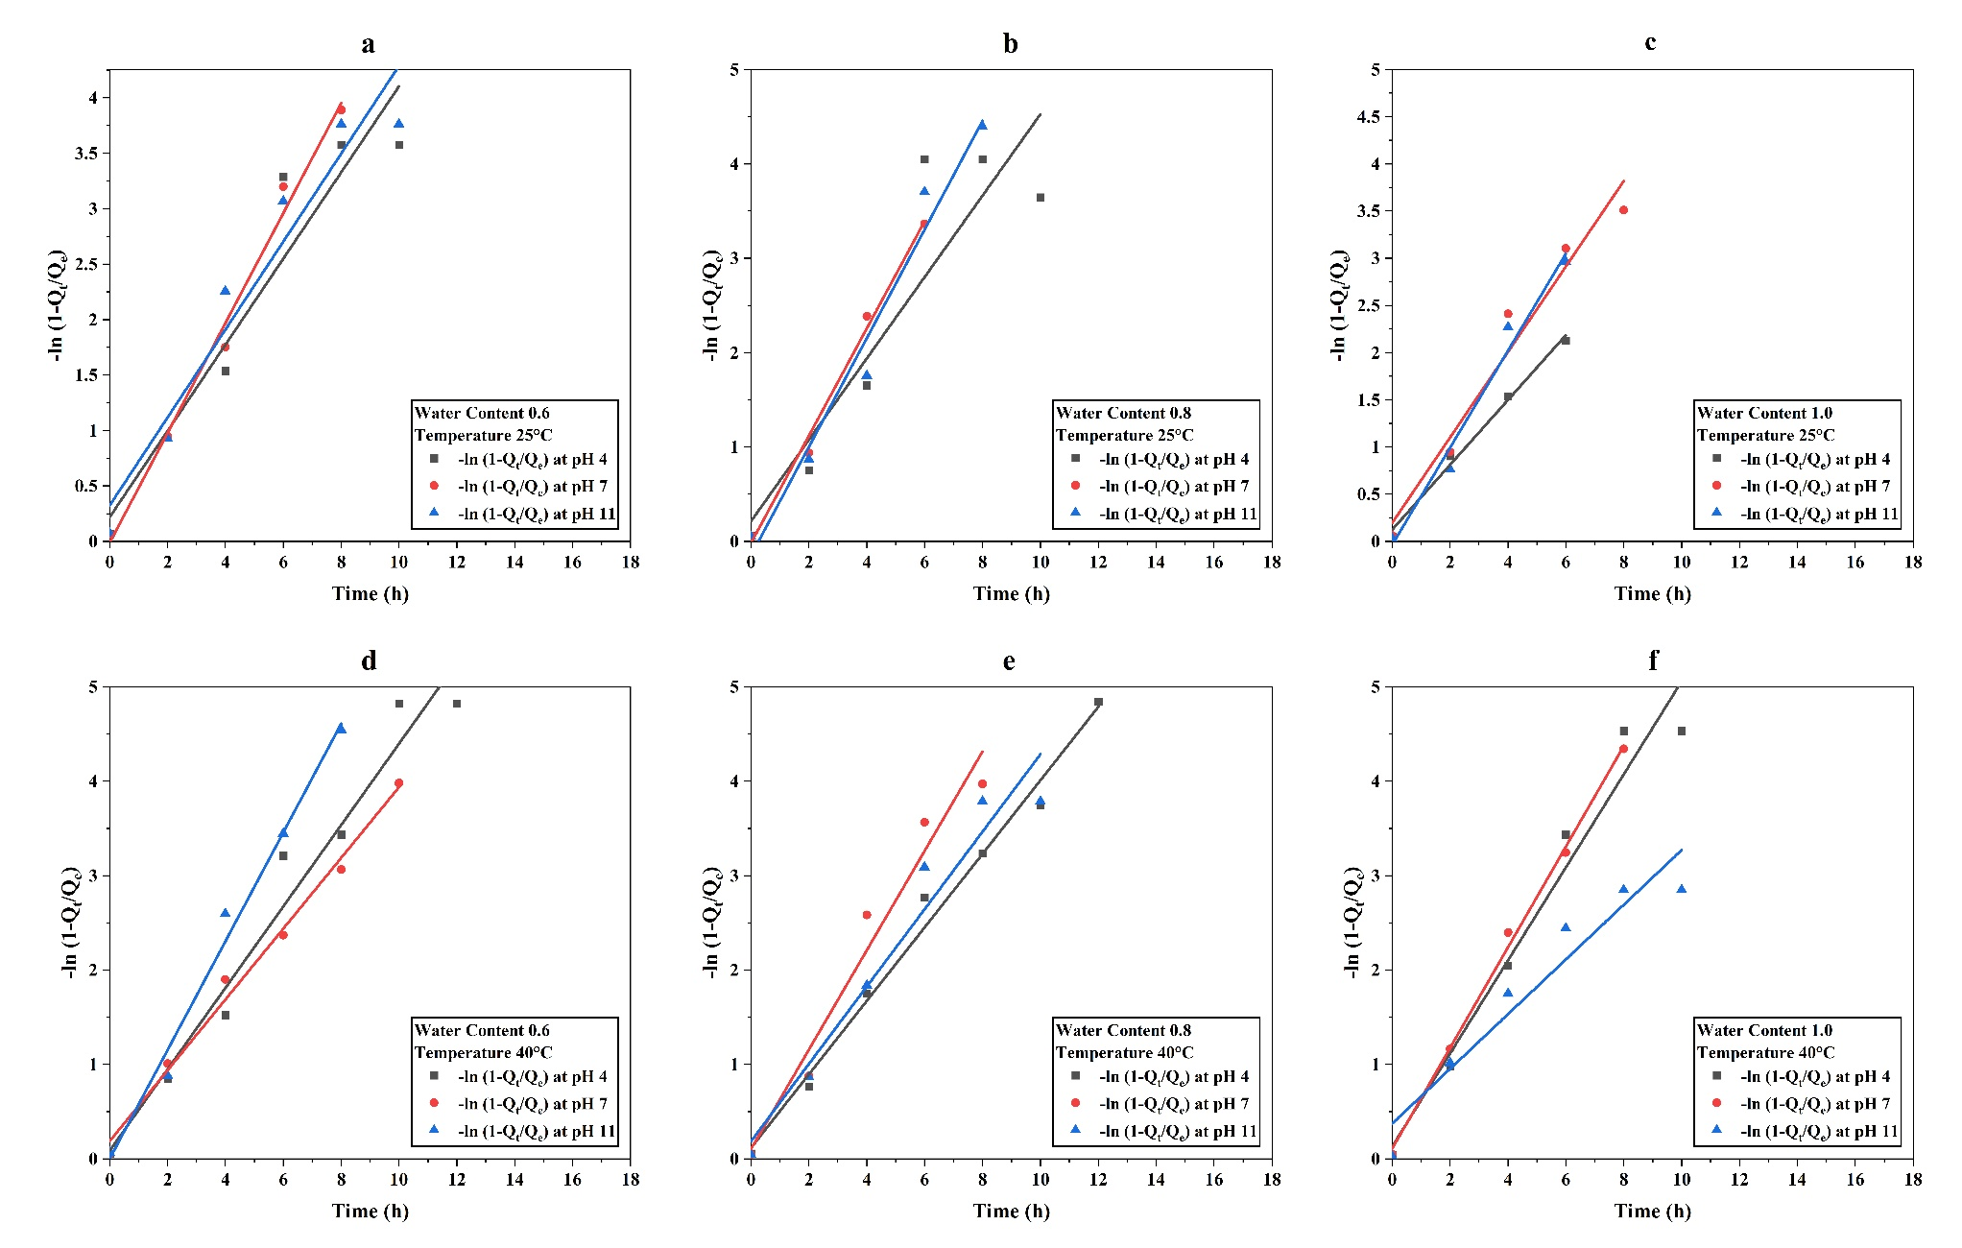

Figure 7: Liquid film diffusion curves for Cr into the sand

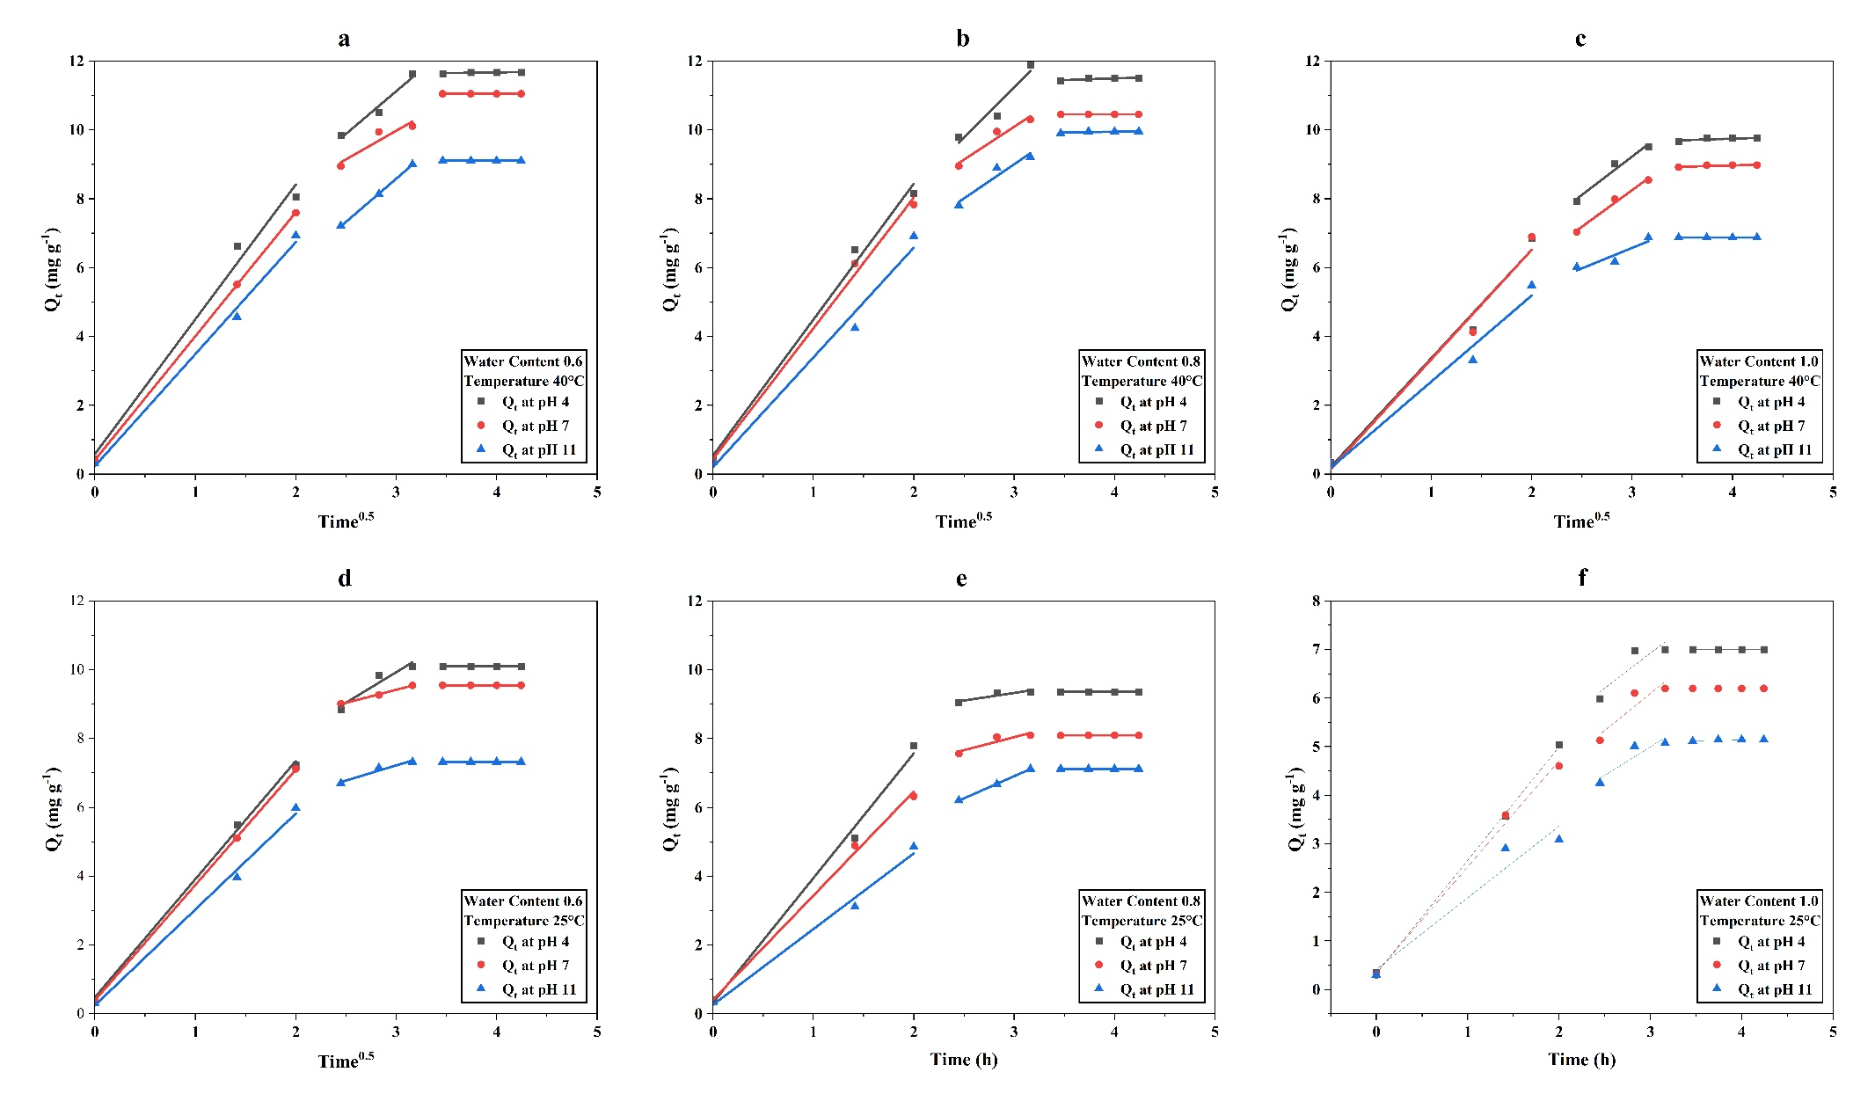

Figure 8: Intra particle diffusion curves for Cr into the soil

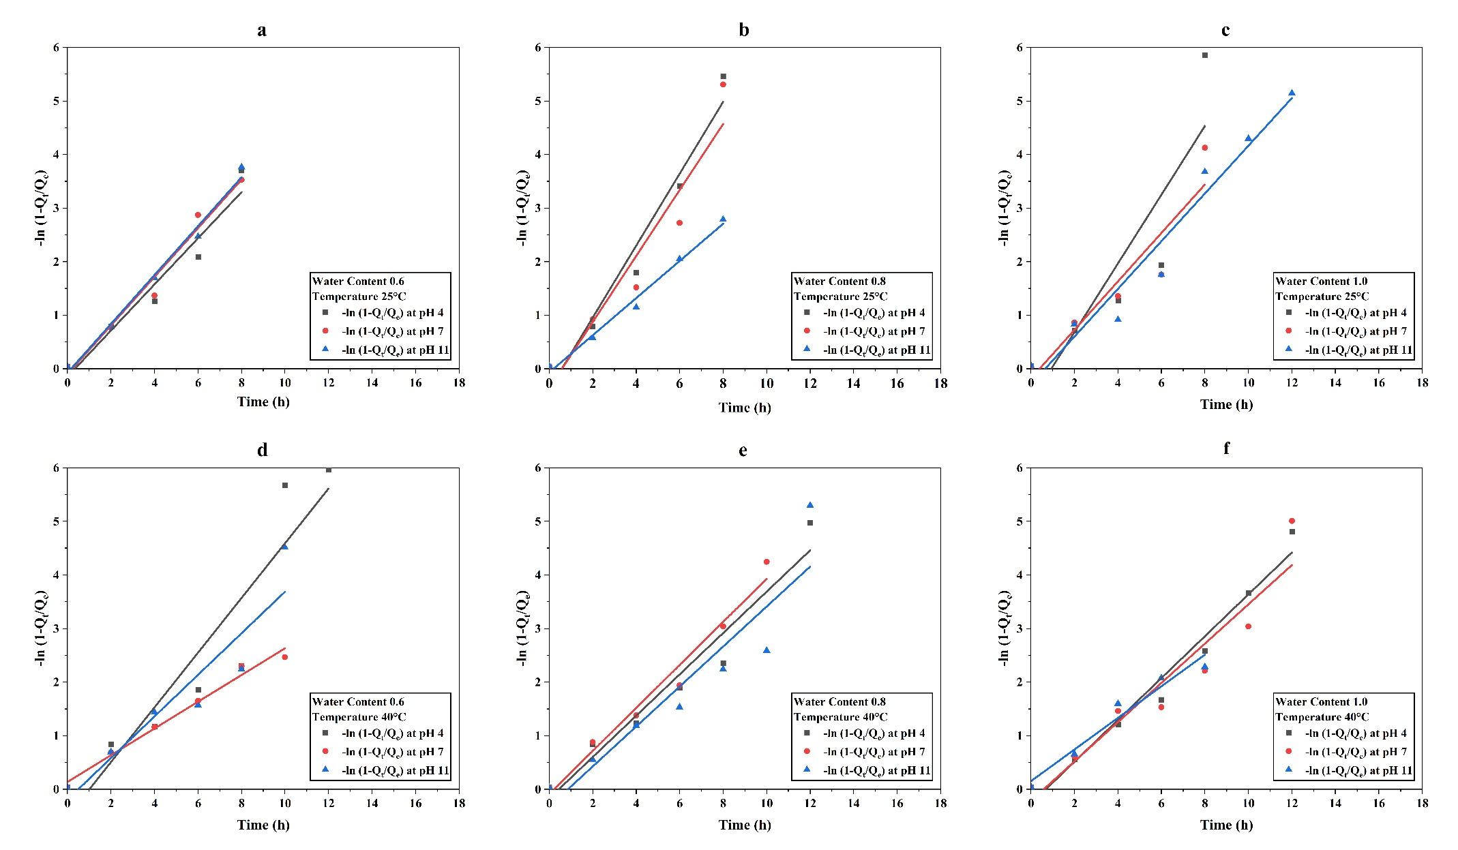

Figure 9: Liquid film diffusion curves for Cr into the soil

1.**Pseudo-first-order equation**

$\frac{{dQ}_{t}}{dt}=k_{1}(Q_{e}-Q_{t})$ (1)

After solving the equation

$Q_{t}=Q_{e}(1-e^{{-tk}_{1}})$ (2)

Plot scatter curve between Qt vs t further apply nonlinear Boxlucas 1 equation in Origin Pro. From there: a = Qe and b = k1

**2. Pseudo-second-order equation**

$\frac{{dQ}_{t}}{dt}=k_{1}{(Q_{e}-Q_{t})}^{2}$ (3)

$Q_{t}=\frac{Q_{e}^{2}k_{2}t}{Q_{e}k_{2}t+1}$ (4)

Plot Qt vs t nonlinear curve in Origin Pro by setting this formula and we will get the value of Qe and k2.

**3. Intra Particle Diffusion**

$Q_{t}=k_{i}t^{1/2}+C$ (5)

Compare the equation with line equation; y = mx + c

M = ki and C = Ci, hence, plot the scatter plot between Qt vs t1/2 and apply linear fitting in Origin Pro.

**4. Liquid Film Diffusion**

$-\ln\left(1-{Q_{t}}/{q_{e}}\right)= k_{f}t$ (6)

Plot the scatter plot between $-\ln\left(1-{Q_{t}}/{q_{e}}\right)$ vs t and apply linear fitting in Origin Pro. Slope m will provide the value of kf.

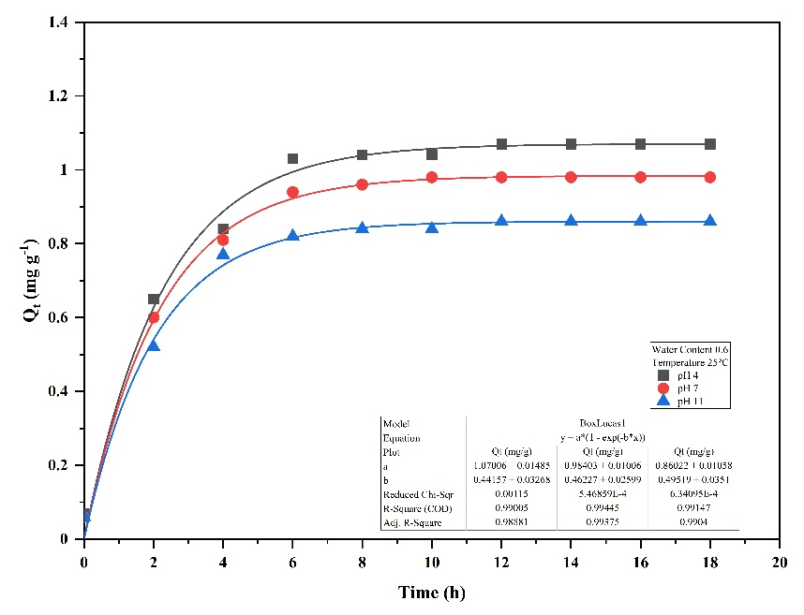

Fig. S1: PFO adsorption kinetics of Cr in sandy soil at pH 4, 7, and 11 under 25°C and WC 0.6

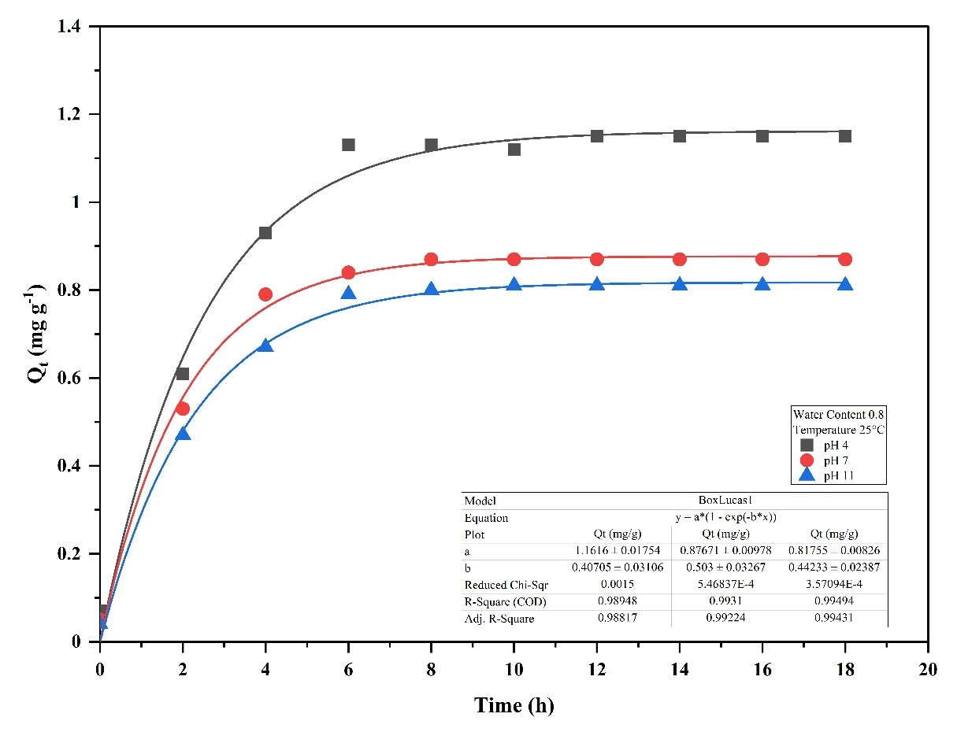

Fig. S2: PFO adsorption kinetics of Cr in sandy soil at pH 4, 7, and 11 under 25°C and WC 0.8

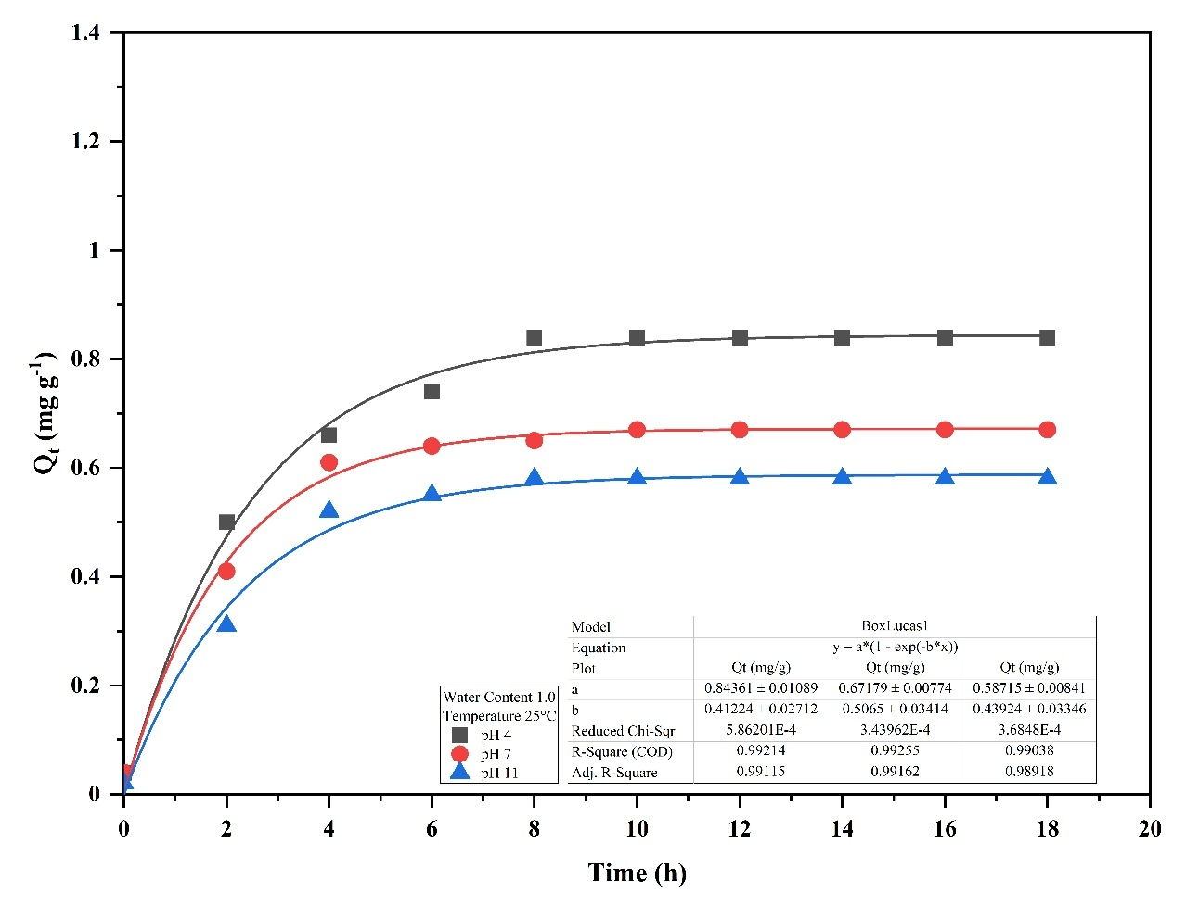

Fig. S3: PFO adsorption kinetics of Cr in sandy soil at pH 4, 7, and 11 under 25°C and WC 1.0

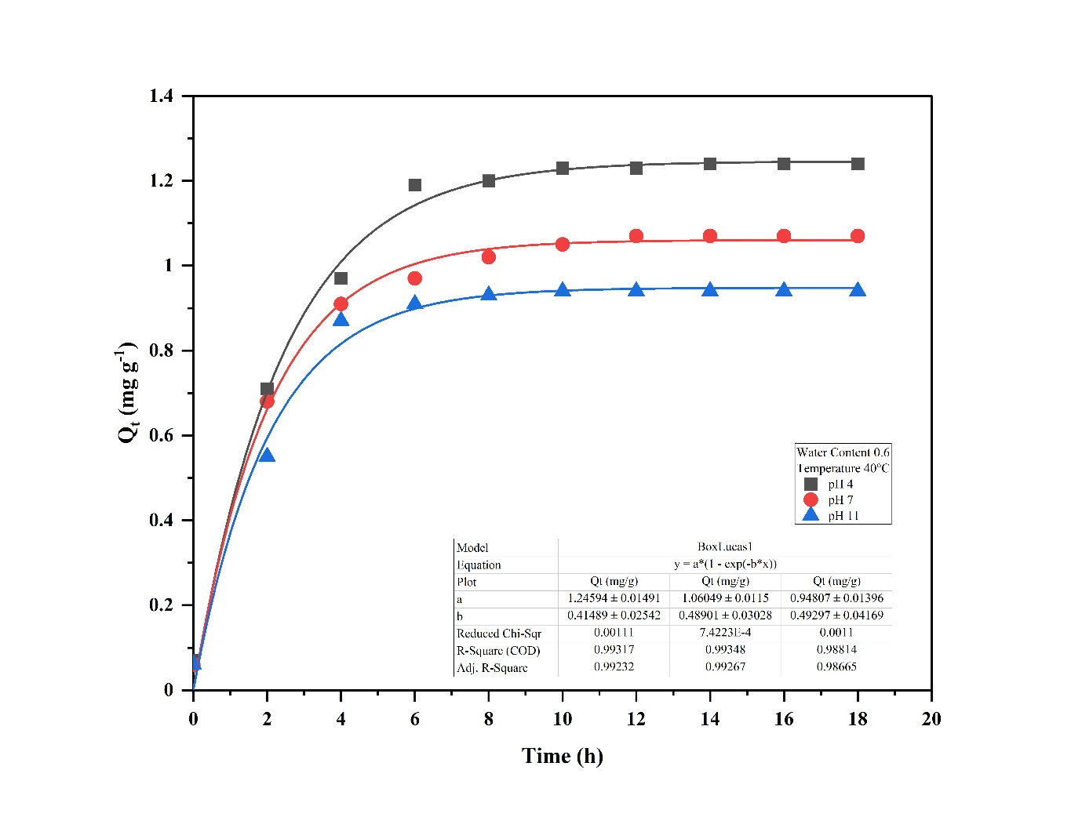

Fig. S4: PFO adsorption kinetics of Cr in sandy soil at pH 4, 7, and 11 under 40°C and WC 0.6

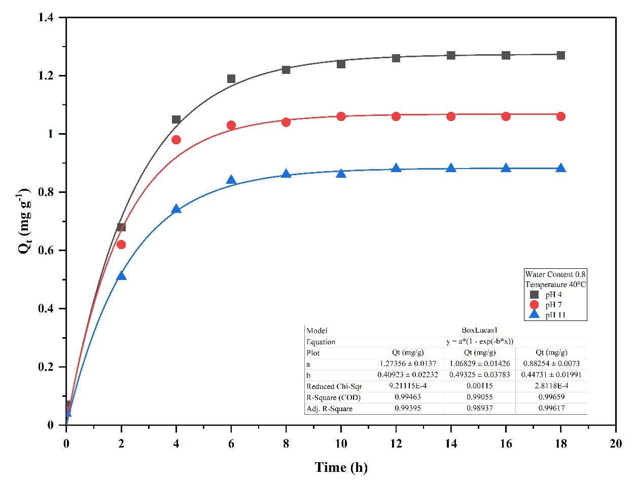

Fig. S5: PFO adsorption kinetics of Cr in sandy soil at pH 4, 7, and 11 under 40°C and WC 0.8

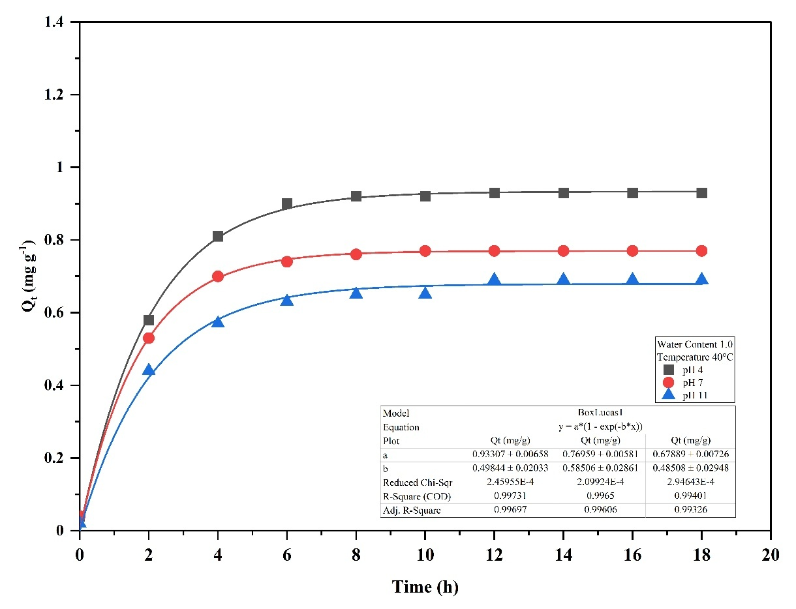

Fig. S6: PFO adsorption kinetics of Cr in sandy soil at pH 4, 7, and 11 under 40°C and WC 1.0

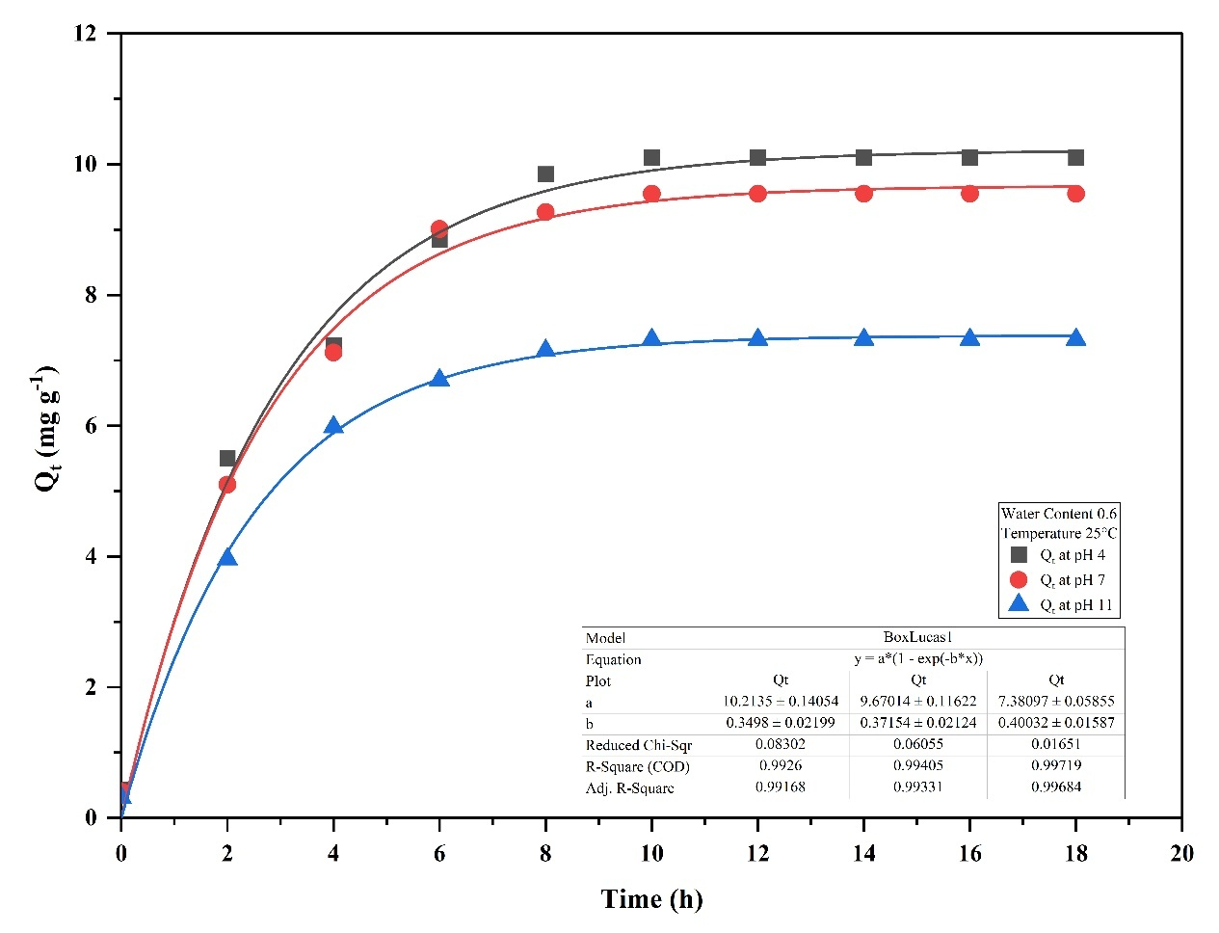

Fig. S7: PFO adsorption kinetics of Cr in Rania soil at pH 4, 7, and 11 under 25°C and WC 0.6

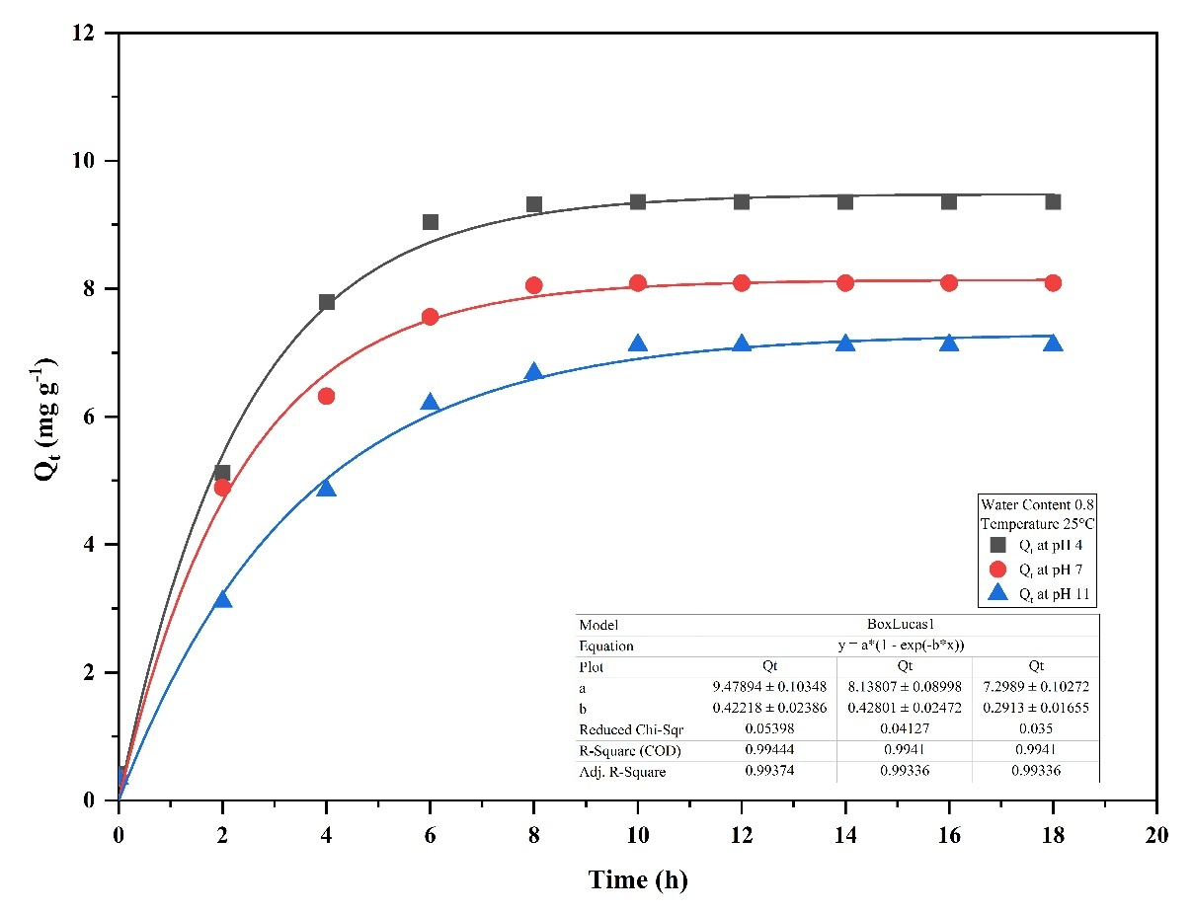

Fig. S8: PFO adsorption kinetics of Cr in Rania soil at pH 4, 7, and 11 under 25°C and WC 0.8

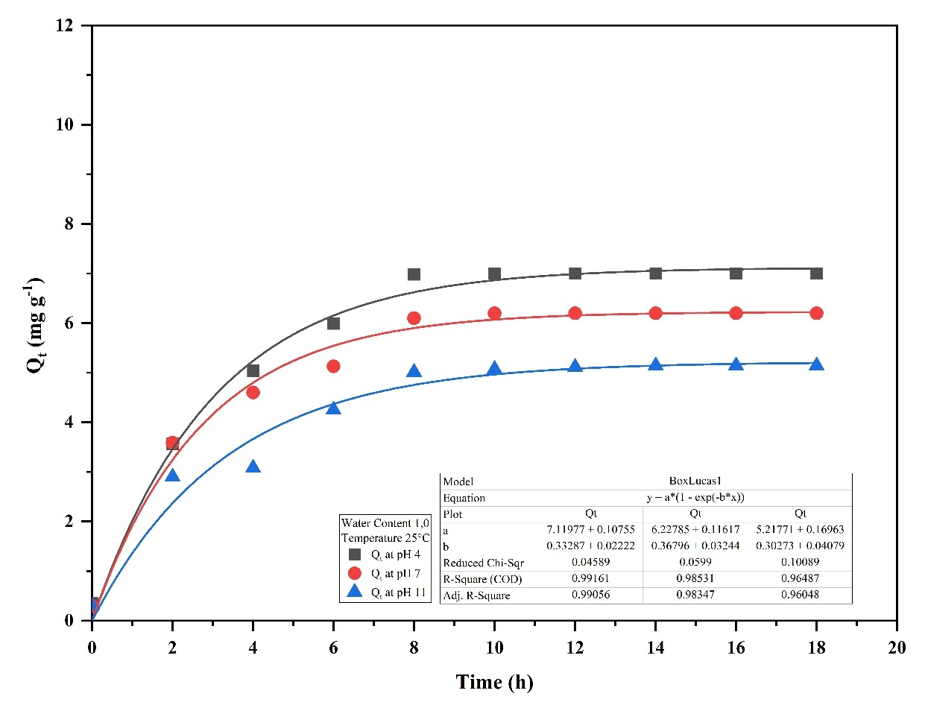

Fig. S9: PFO adsorption kinetics of Cr in Rania soil at pH 4, 7, and 11 under 25°C and WC 1.0

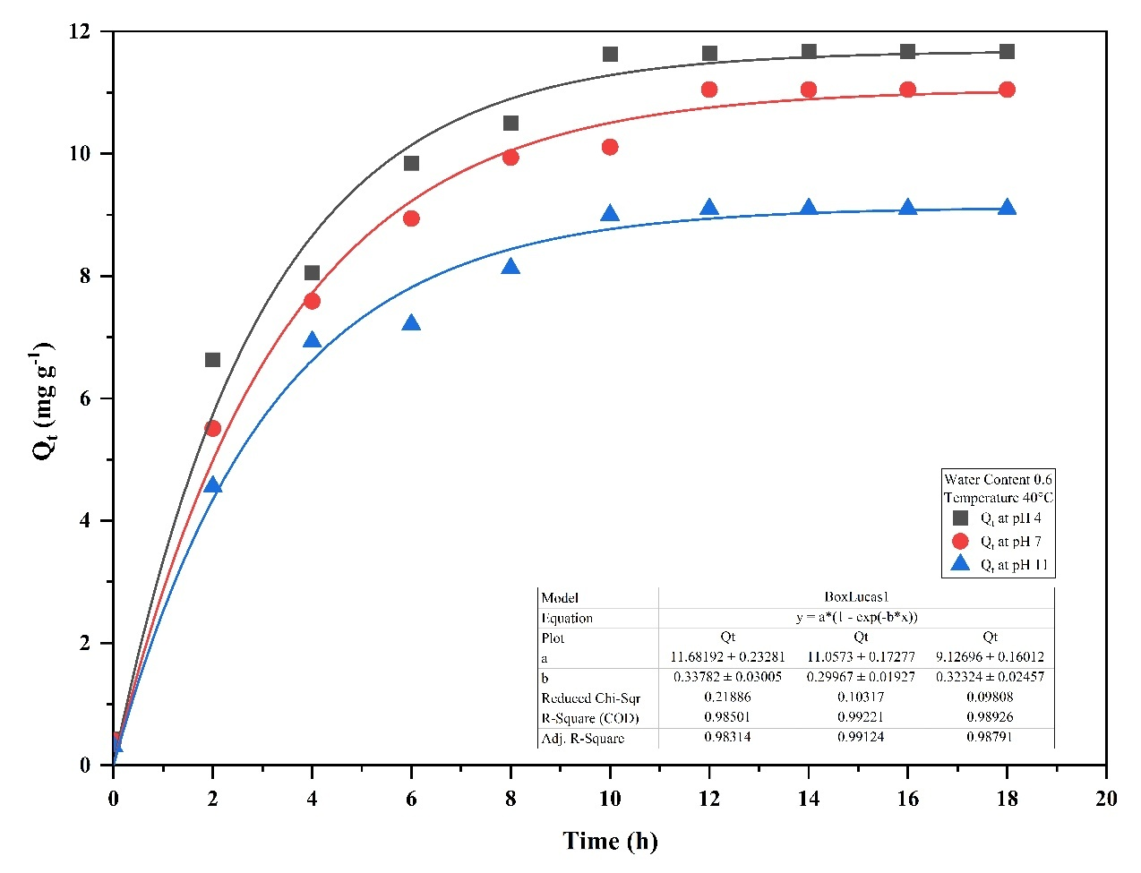

Fig. S10: PFO adsorption kinetics of Cr in Rania soil at pH 4, 7, and 11 under 40°C and WC 0.6

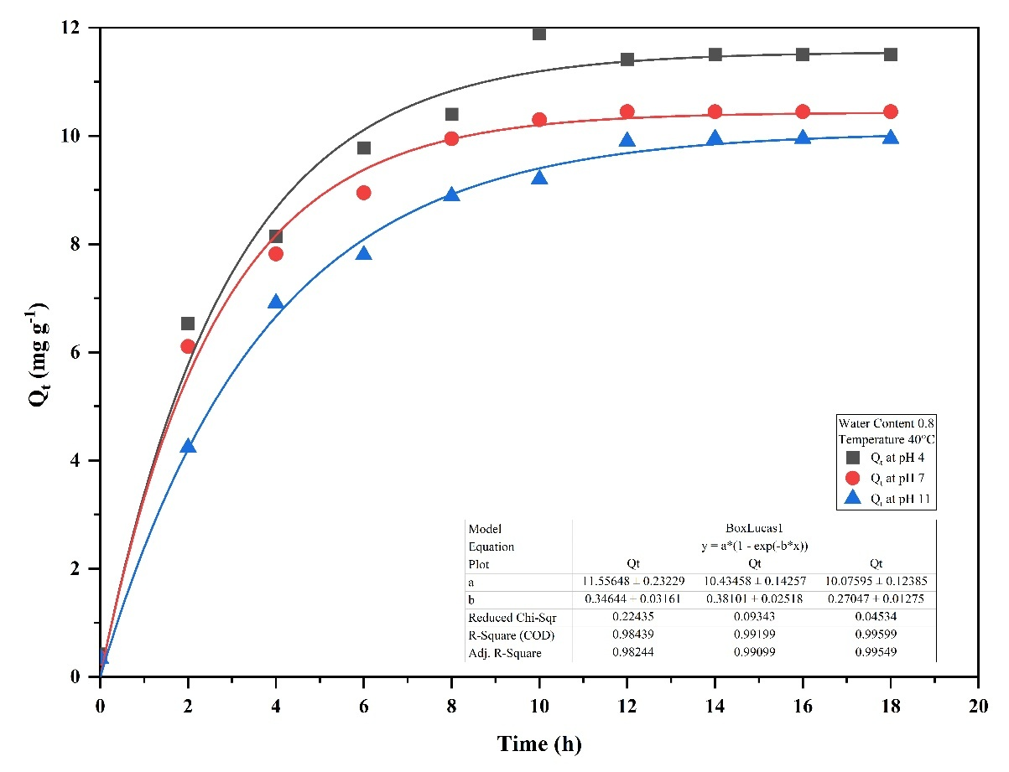

Fig. S11: PFO adsorption kinetics of Cr in Rania soil at pH 4, 7, and 11 under 40°C and WC 0.8

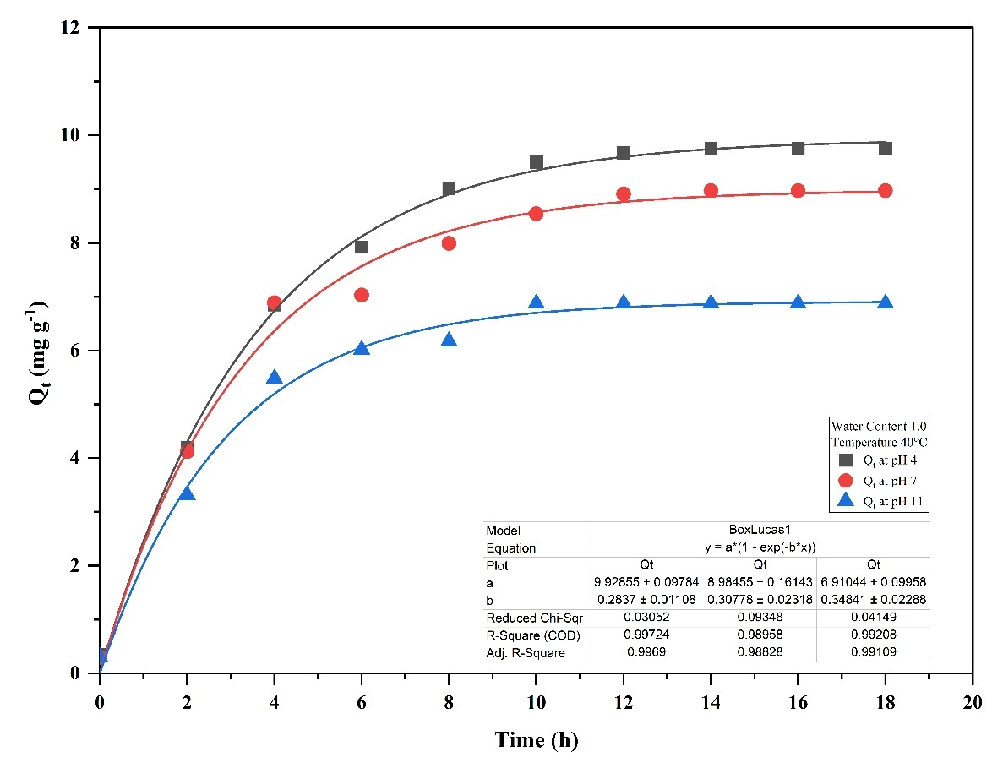

Fig. S12: PFO adsorption kinetics of Cr in Rania soil at pH 4, 7, and 11 under 40°C and WC 1.0

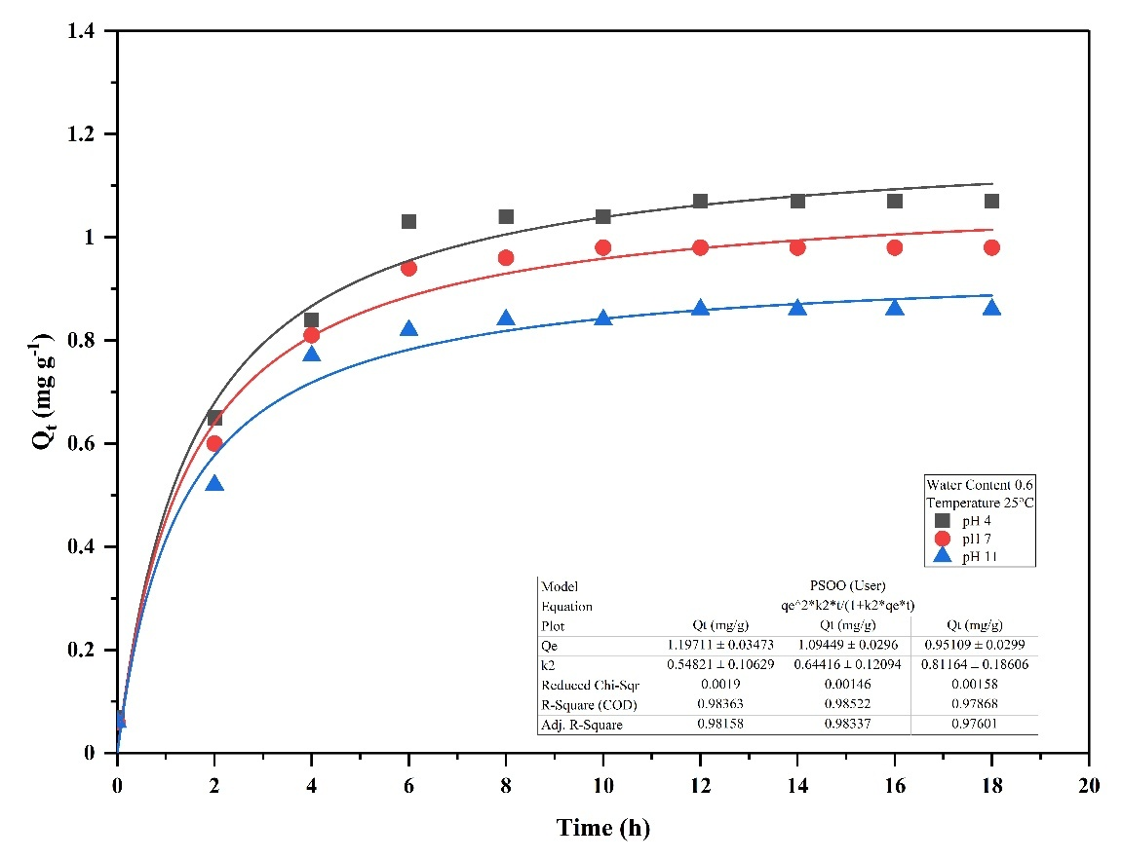

Fig. S13: PSO adsorption kinetics of Cr in sandy soil at pH 4, 7, and 11 under 25°C and WC 0.6

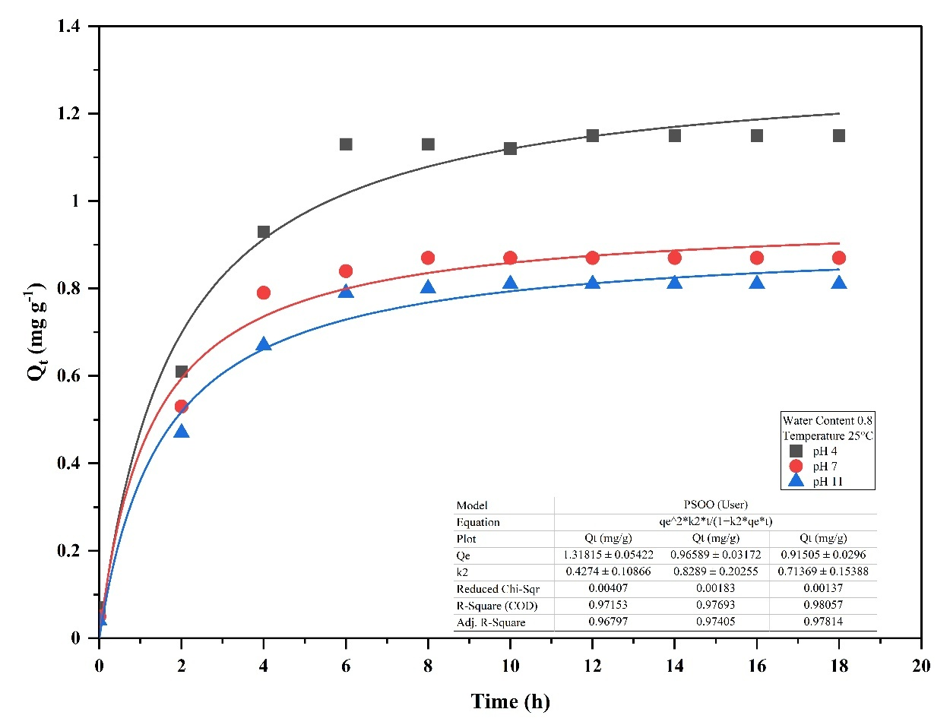

Fig. S14: PSO adsorption kinetics of Cr in sandy soil at pH 4, 7, and 11 under 25°C and WC 0.8

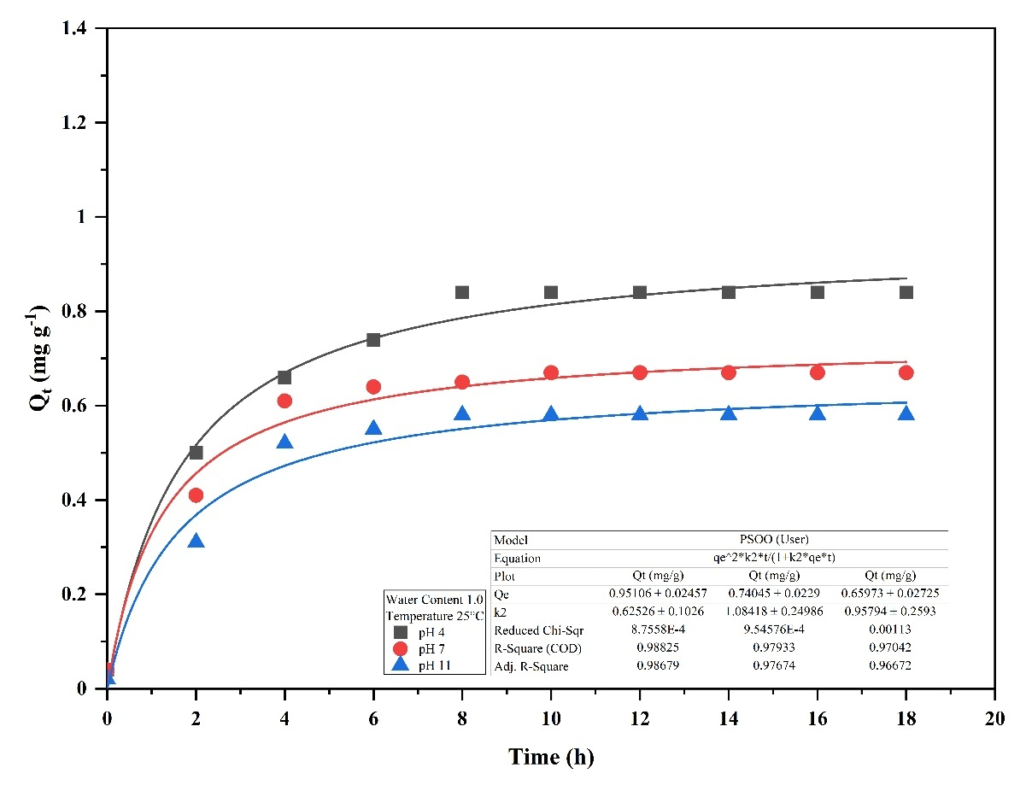

Fig. S15: PSO adsorption kinetics of Cr in sandy soil at pH 4, 7, and 11 under 25°C and WC 1.0

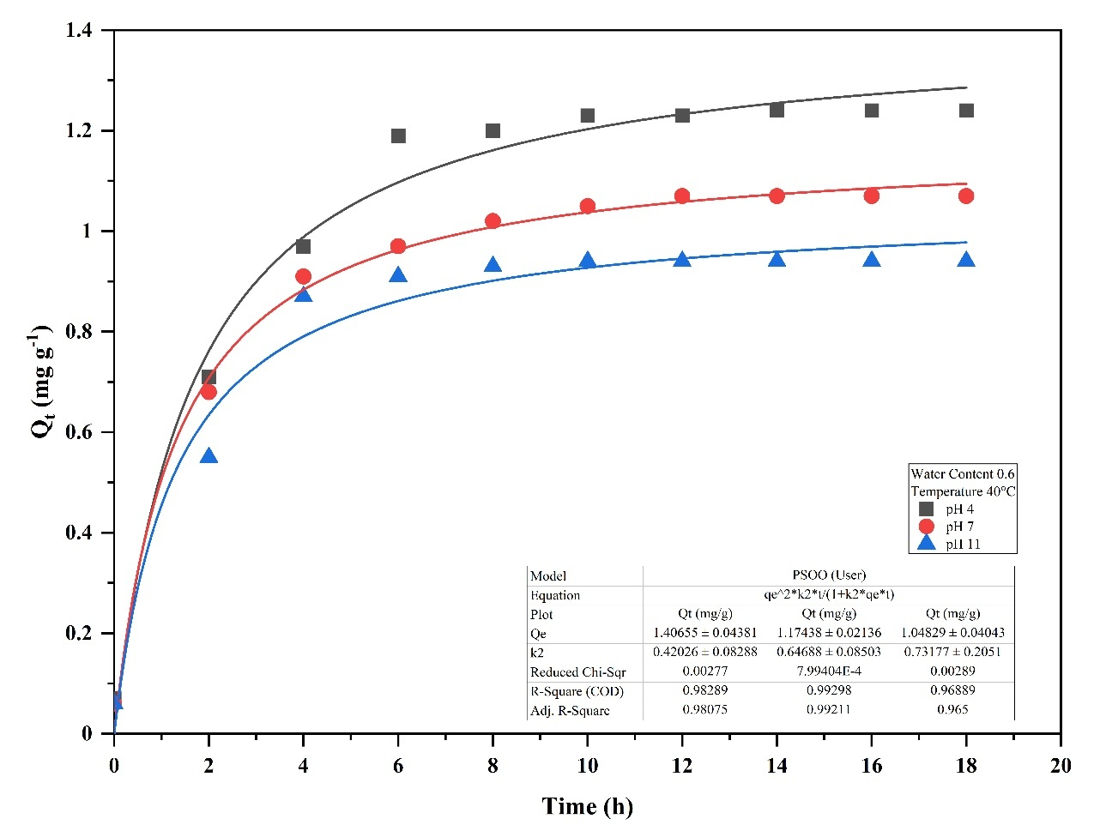

Fig. S16: PSO adsorption kinetics of Cr in sandy soil at pH 4, 7, and 11 under 40°C and WC 0.6

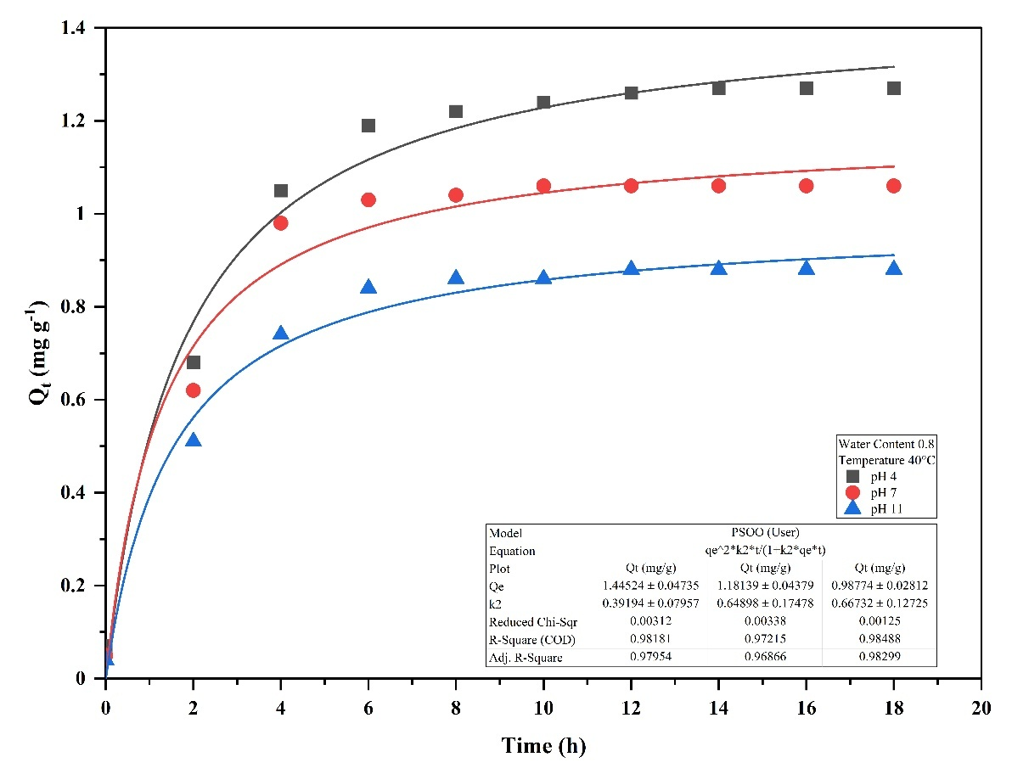

Fig. S17: PSO adsorption kinetics of Cr in sandy soil at pH 4, 7, and 11 under 40°C and WC 0.8

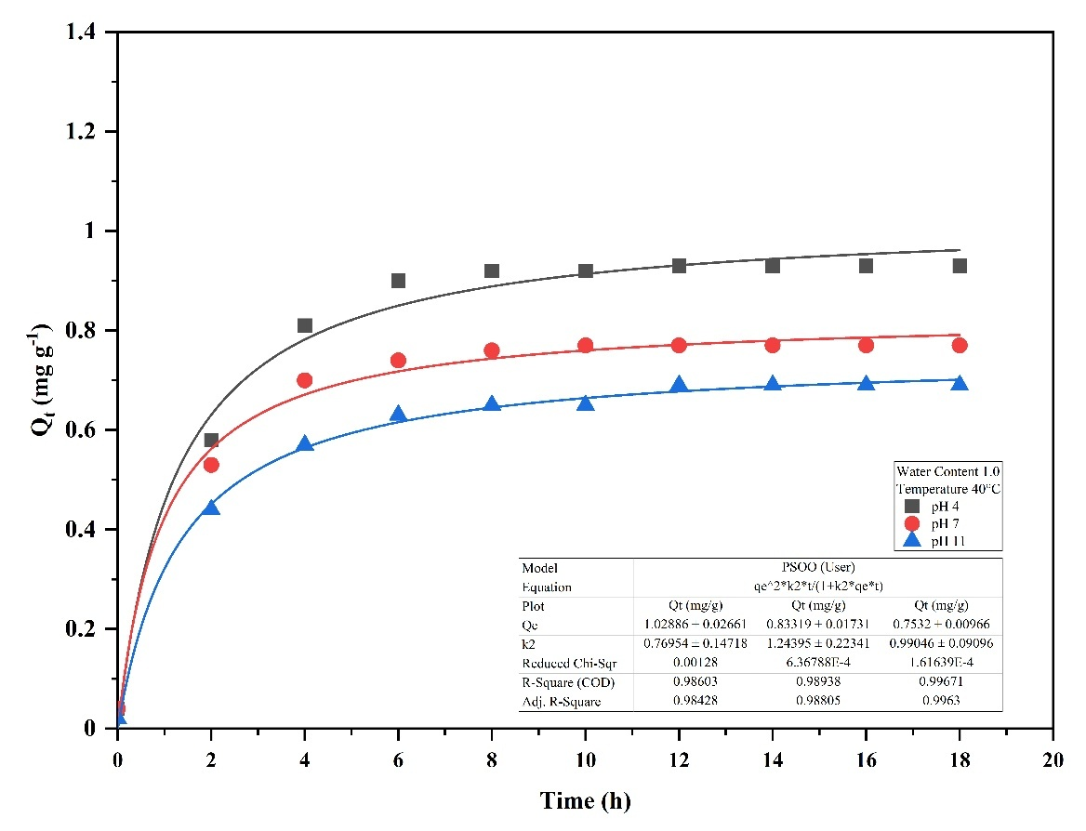

Fig. S18: PSO adsorption kinetics of Cr in sandy soil at pH 4, 7, and 11 under 40°C and WC 0.6

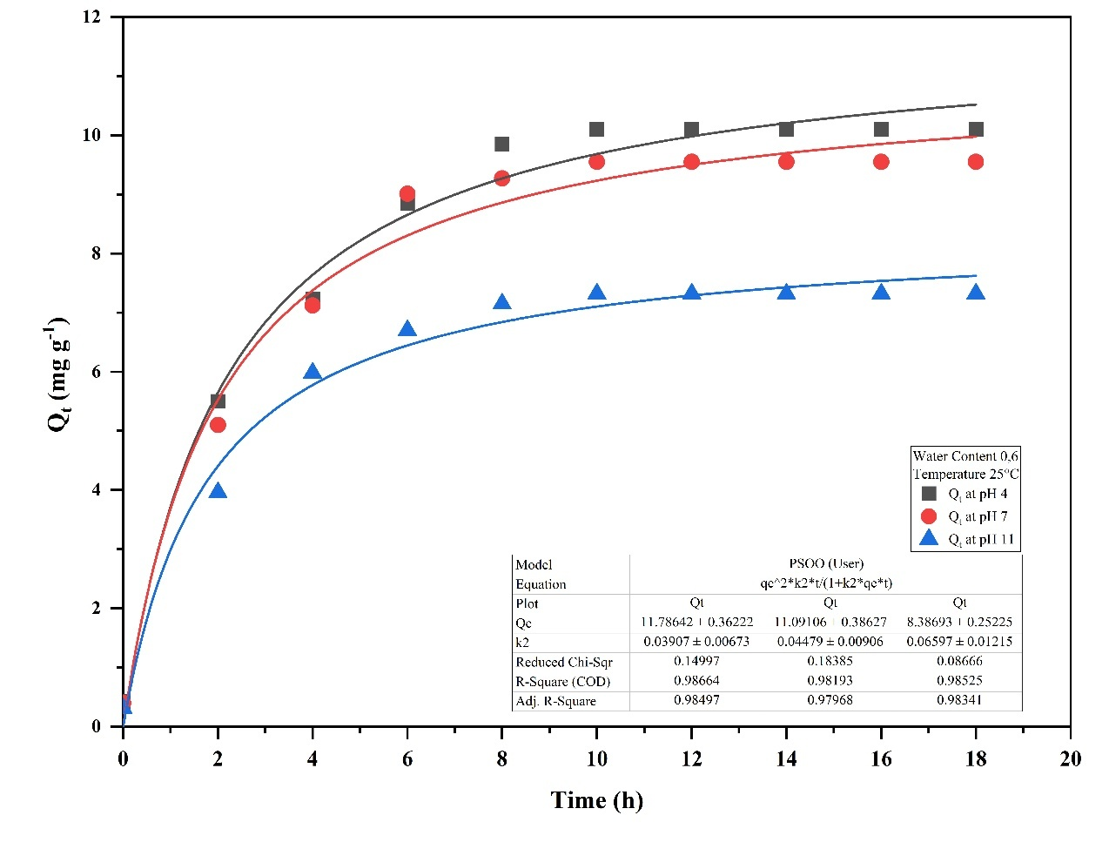

Fig. S19: PSO adsorption kinetics of Cr in Rania soil at pH 4, 7, and 11 under 25°C and WC 0.6

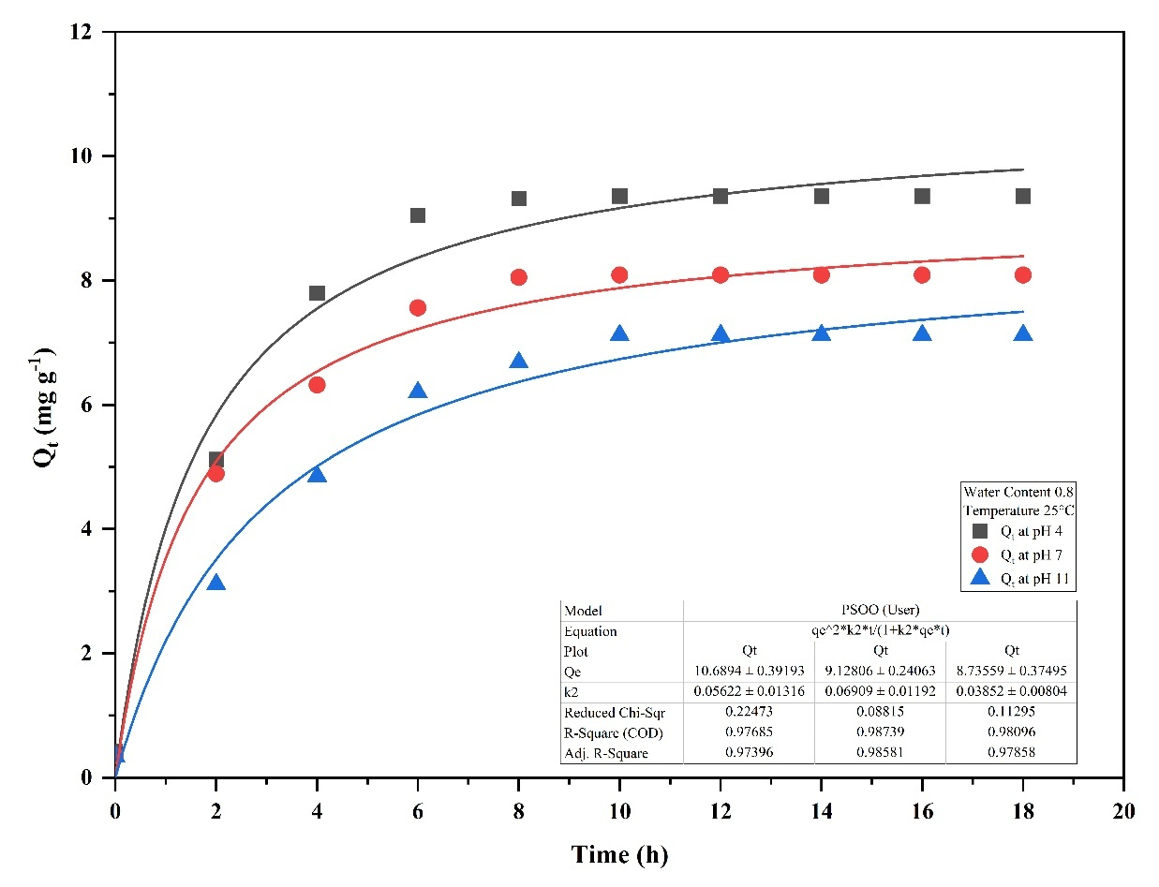

Fig. S20: PSO adsorption kinetics of Cr in Rania soil at pH 4, 7, and 11 under 25°C and WC 0.8

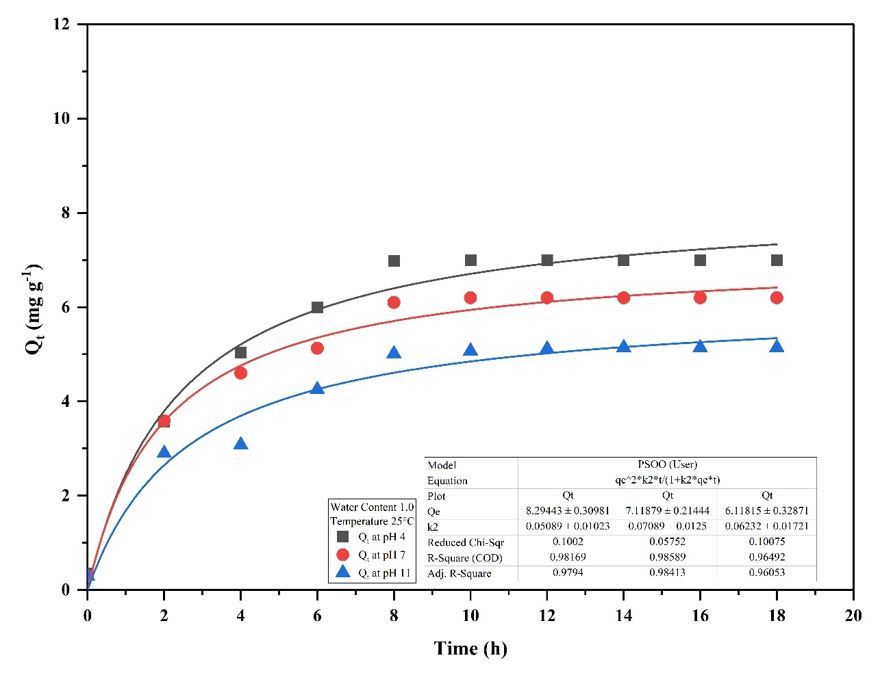

Fig. S21: PSO adsorption kinetics of Cr in Rania soil at pH 4, 7, and 11 under 25°C and WC 1.0

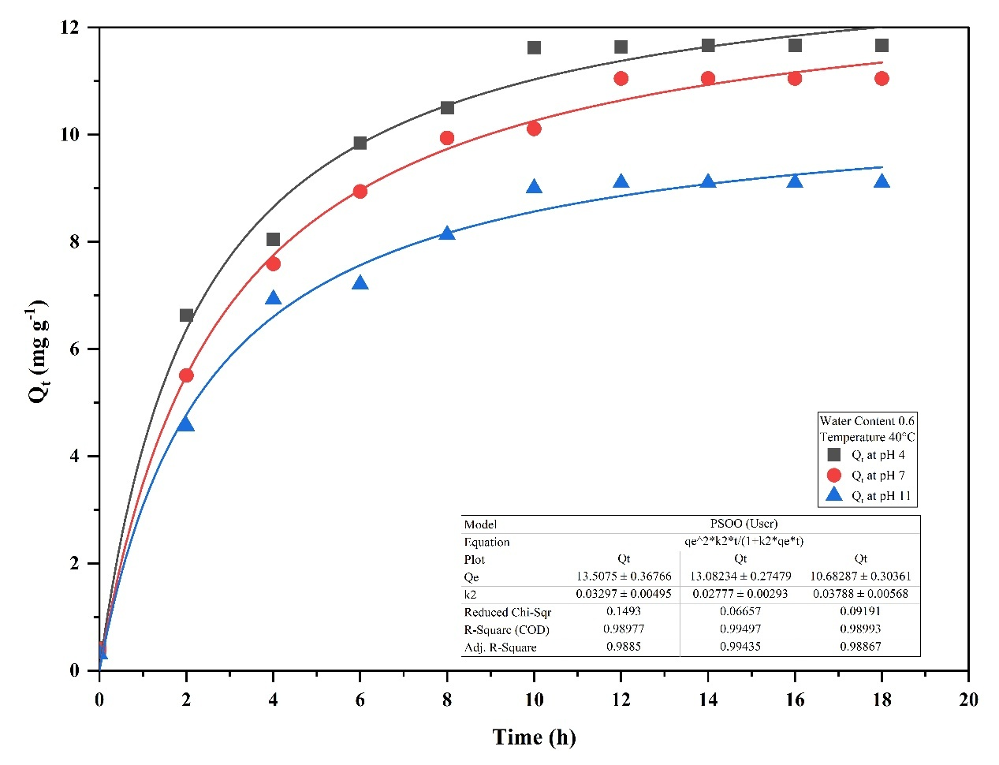

Fig. S22: PSO adsorption kinetics of Cr in Rania soil at pH 4, 7, and 11 under 40°C and WC 0.6

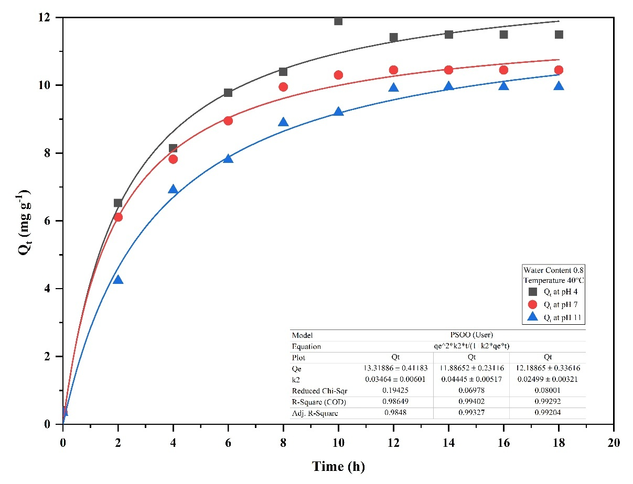

Fig. S23: PSO adsorption kinetics of Cr in Rania soil at pH 4, 7, and 11 under 40°C and WC 0.8

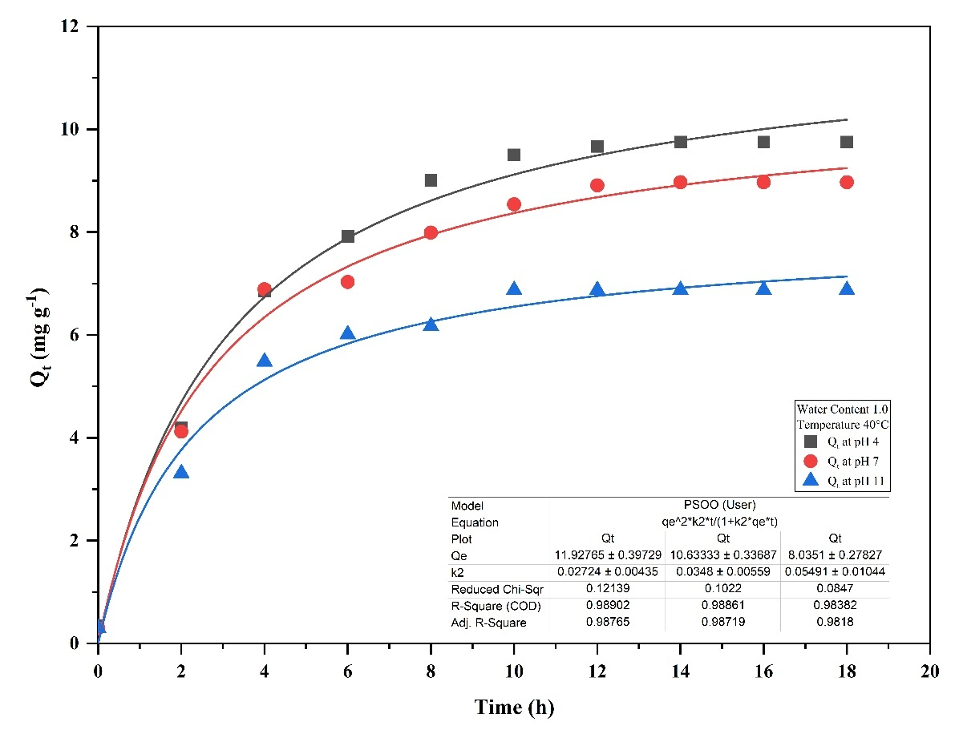

Fig. S24: PSO adsorption kinetics of Cr in Rania soil at pH 4, 7, and 11 under 40°C and WC 1.0

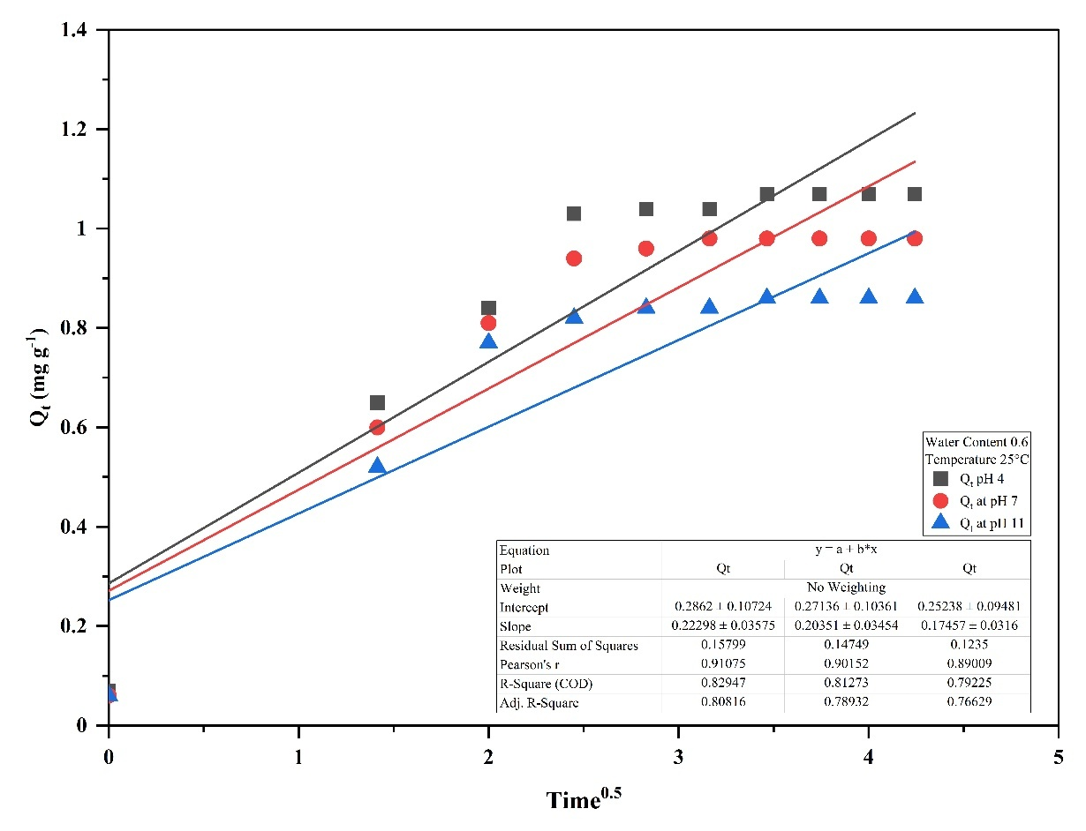

Fig. S25: IPD adsorption kinetics of Cr in sand soil at pH 4, 7, and 11 under 25°C and WC 0.6

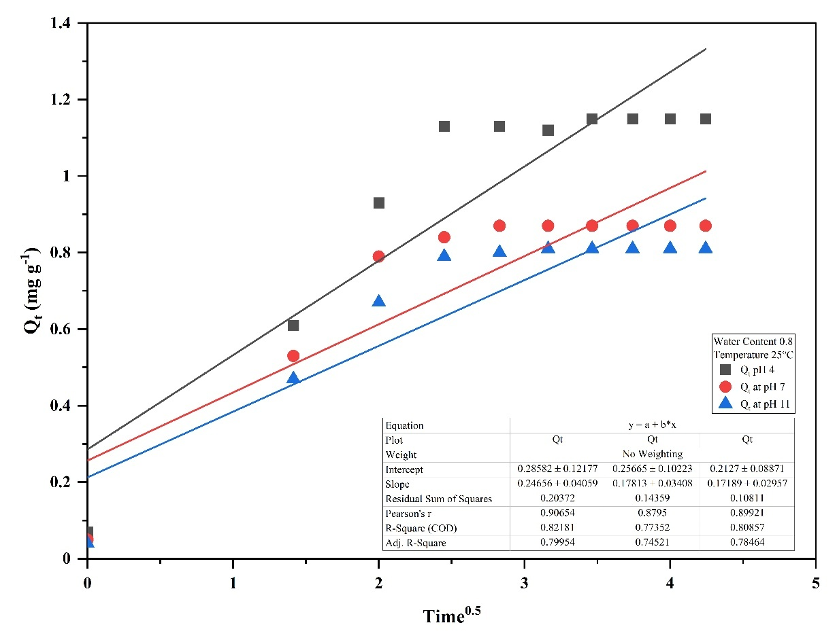

Fig. S26: IPD adsorption kinetics of Cr in sand soil at pH 4, 7, and 11 under 25°C and WC 0.8

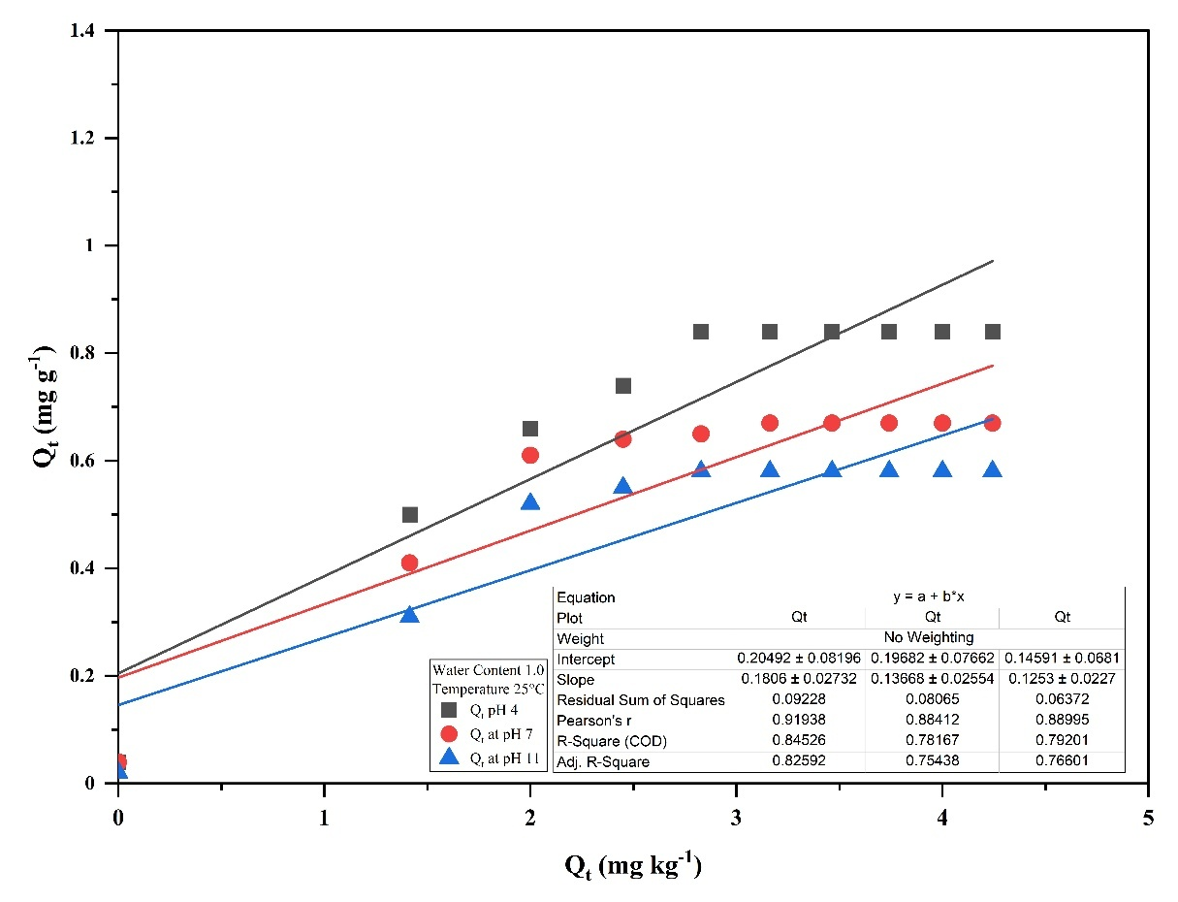

Fig. S27: IPD adsorption kinetics of Cr in sand soil at pH 4, 7, and 11 under 25°C and WC 1.0

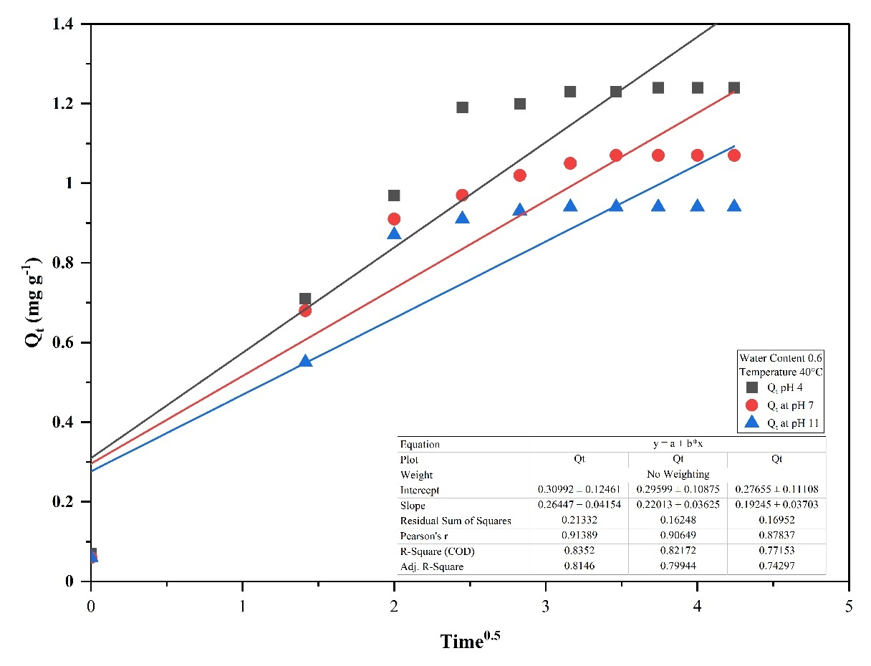

Fig. S28: IPD adsorption kinetics of Cr in sand soil at pH 4, 7, and 11 under 40°C and WC 0.6

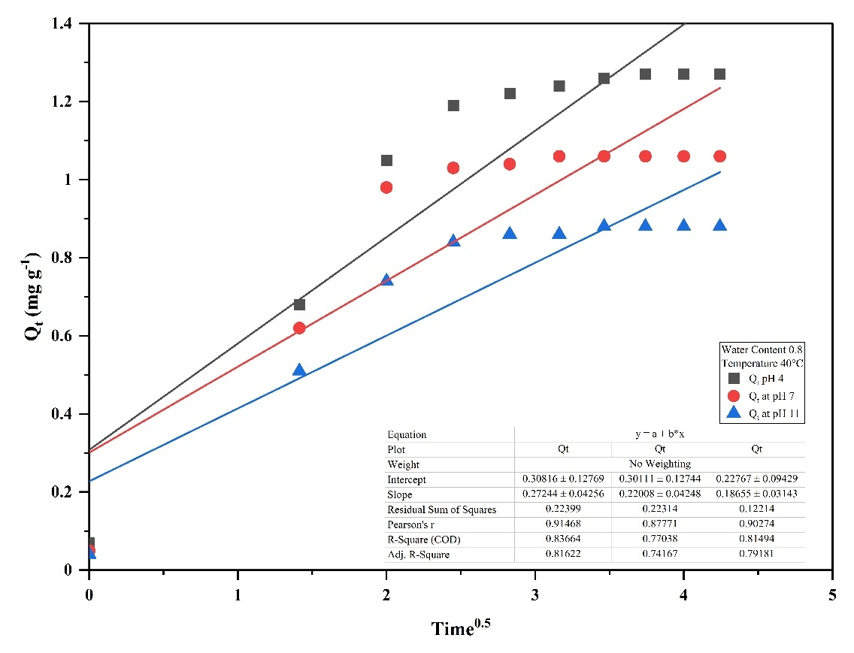

Fig. S29: IPD adsorption kinetics of Cr in sand soil at pH 4, 7, and 11 under 40°C and WC 0.8

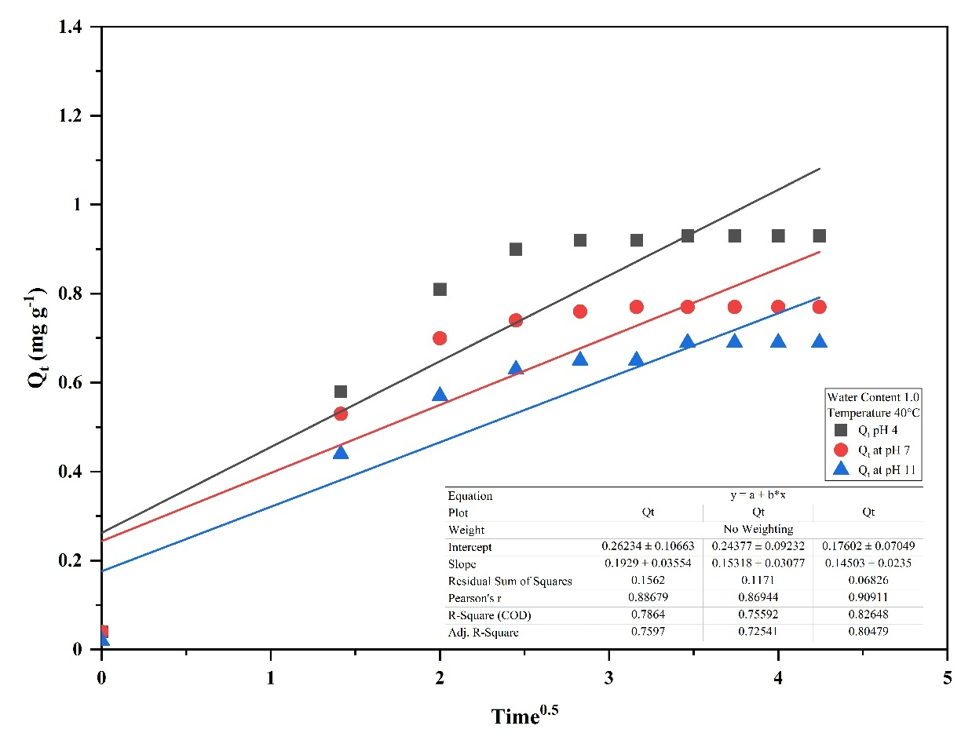

Fig. S30: IPD adsorption kinetics of Cr in sand soil at pH 4, 7, and 11 under 40°C and WC 1.0

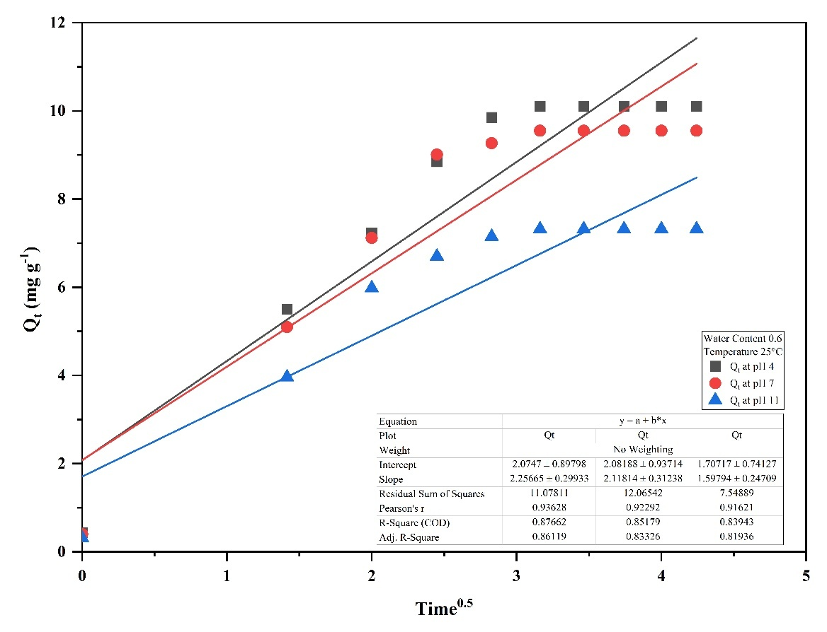

Fig. S31: IPD adsorption kinetics of Cr in Rania soil at pH 4, 7, and 11 under 25°C and WC 0.6

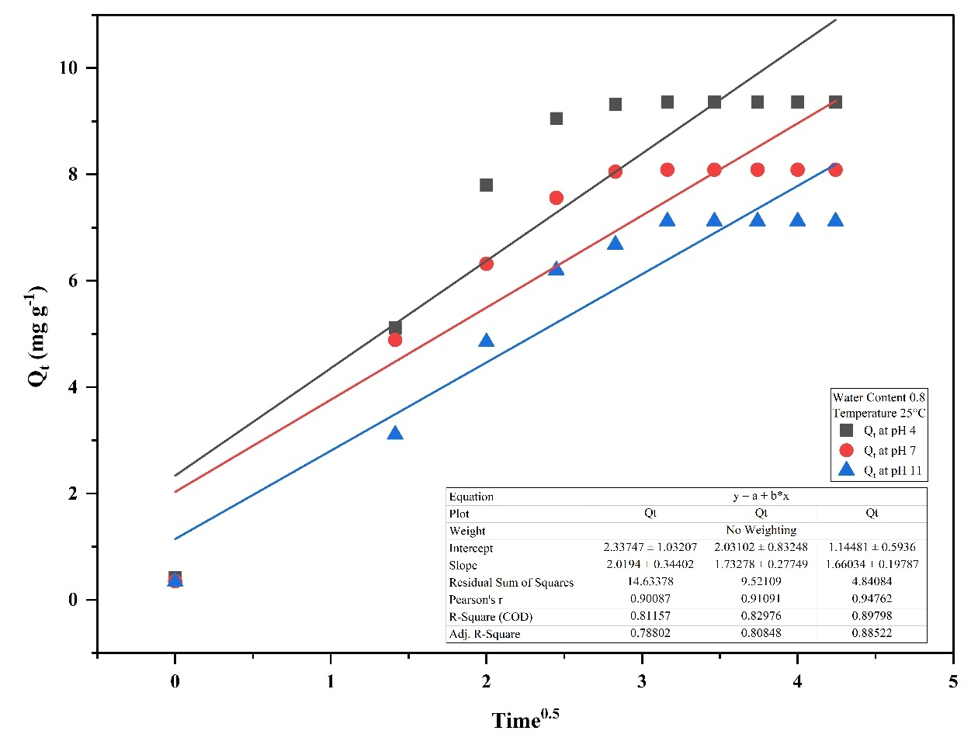

Fig. S32: IPD adsorption kinetics of Cr in Rania soil at pH 4, 7, and 11 under 25°C and WC 0.8

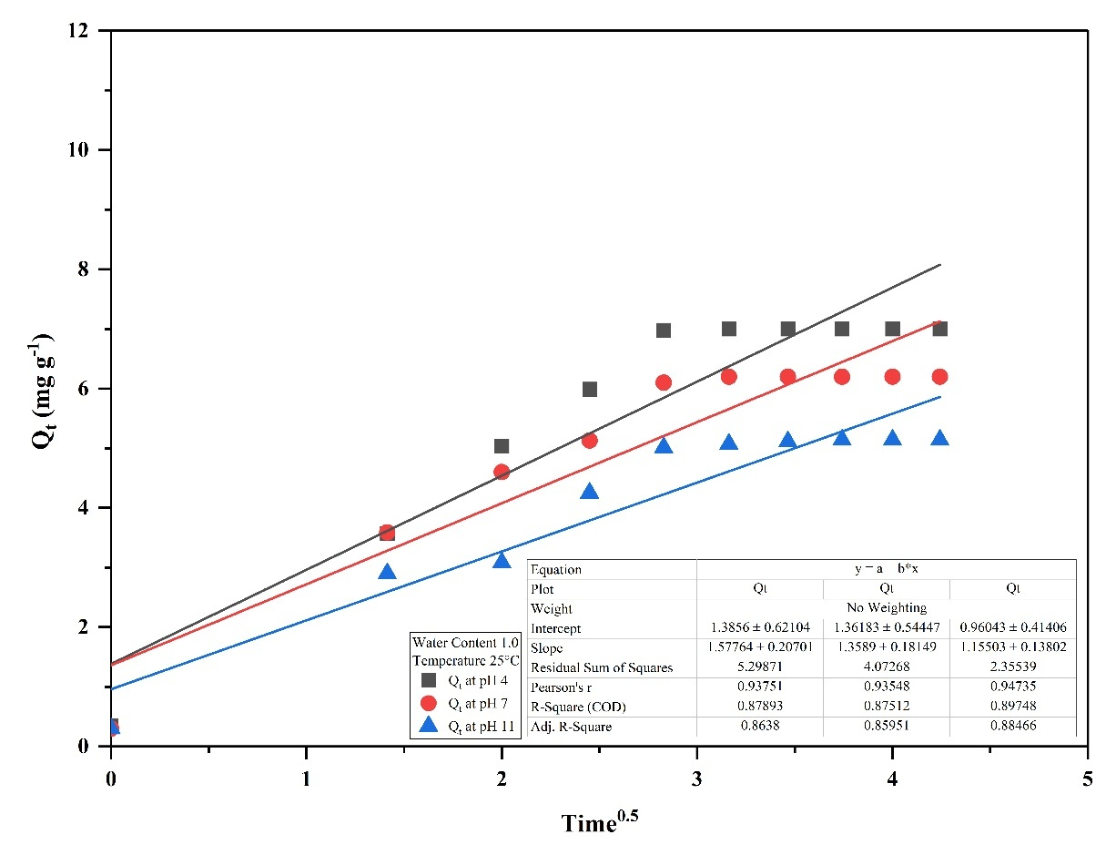

Fig. S33: IPD adsorption kinetics of Cr in Rania soil at pH 4, 7, and 11 under 25°C and WC 1.0

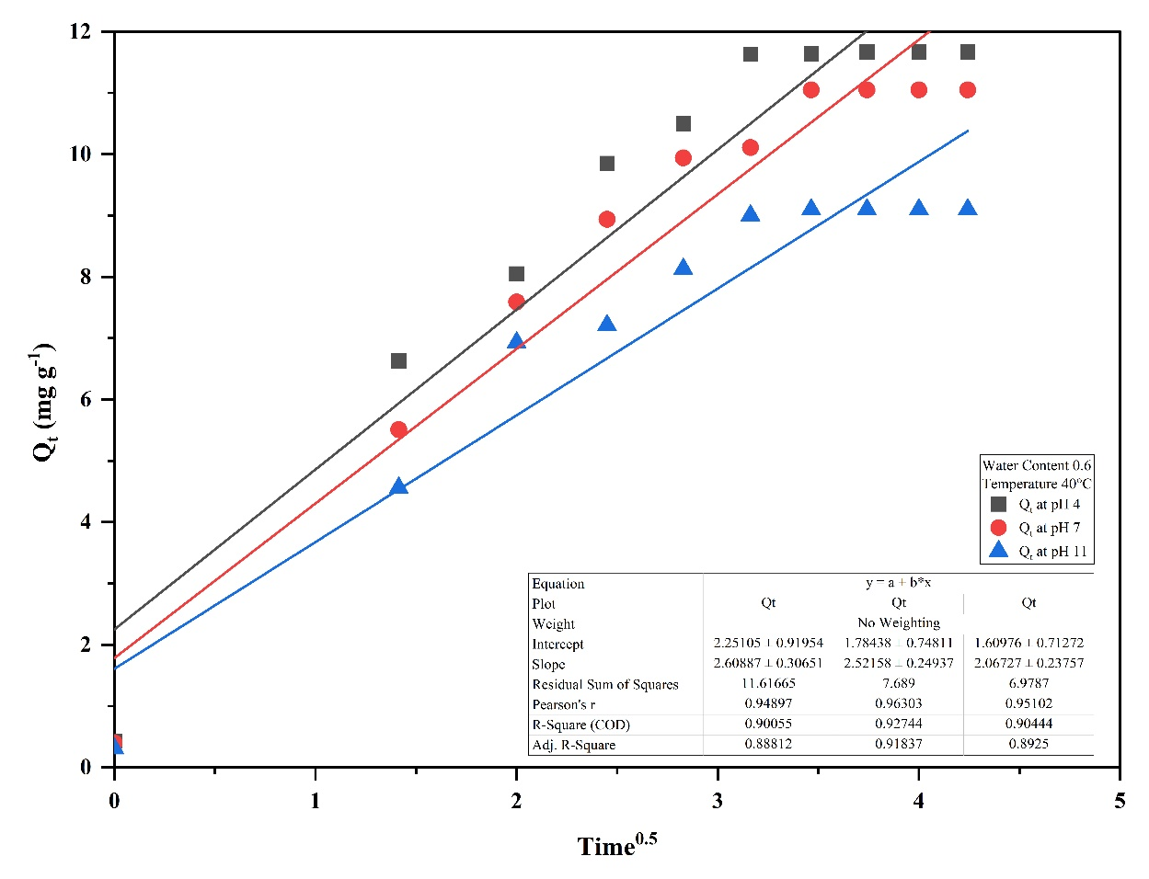

Fig. S34: IPD adsorption kinetics of Cr in Rania soil at pH 4, 7, and 11 under 40°C and WC 0.6

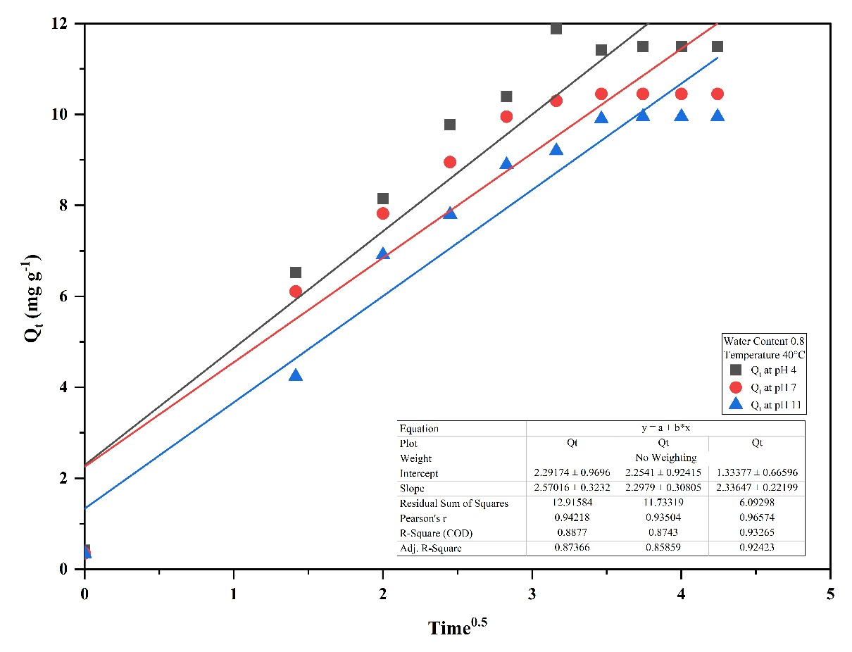

Fig. S35: IPD adsorption kinetics of Cr in Rania soil at pH 4, 7, and 11 under 40°C and WC 0.8

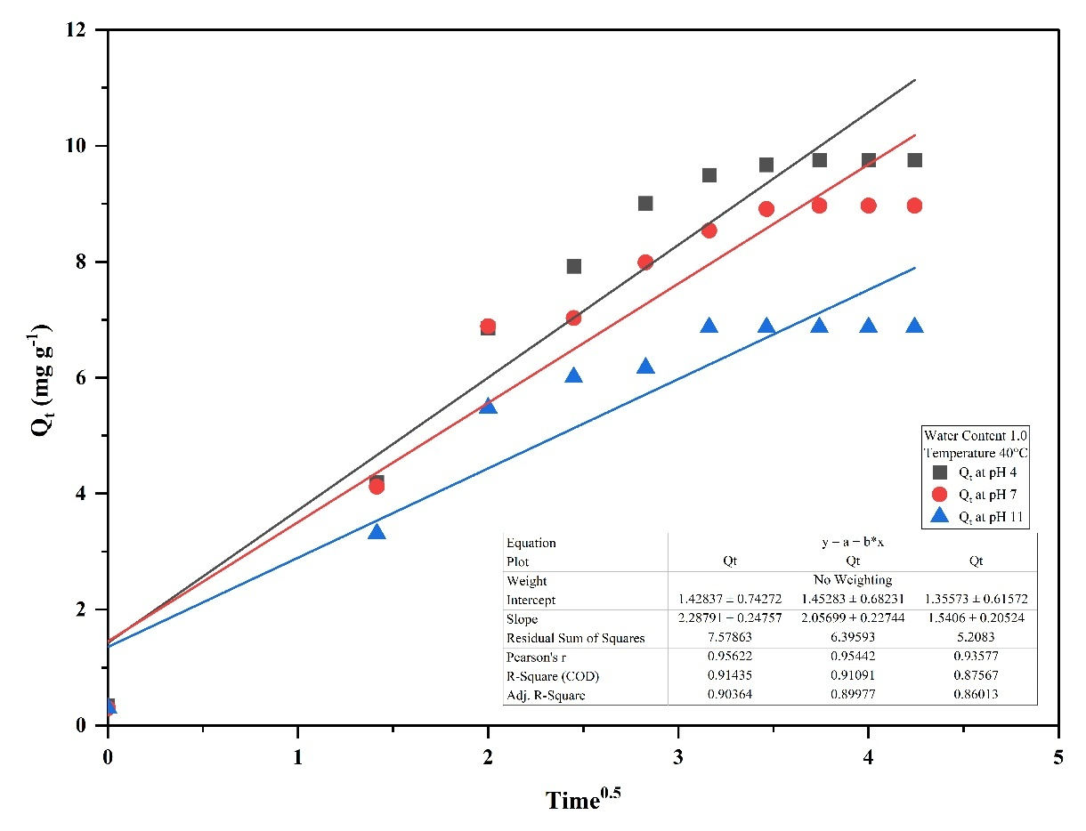

Fig. S36: IPD adsorption kinetics of Cr in Rania soil at pH 4, 7, and 11 under 40°C and WC 1.0

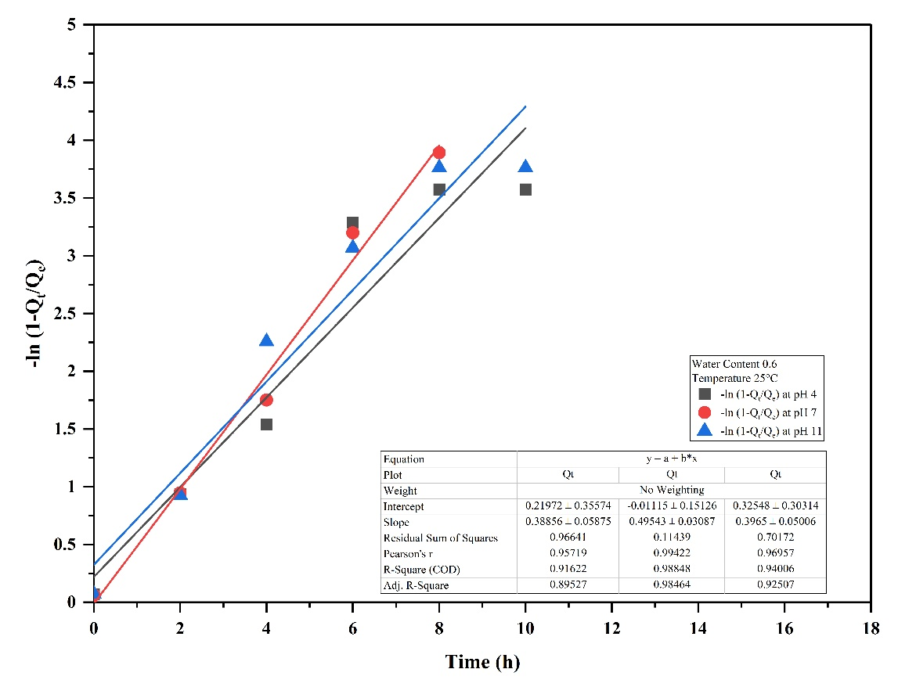

Fig. S37: LFD adsorption kinetics of Cr in sandy soil at pH 4, 7, and 11 under 25°C and WC 0.6

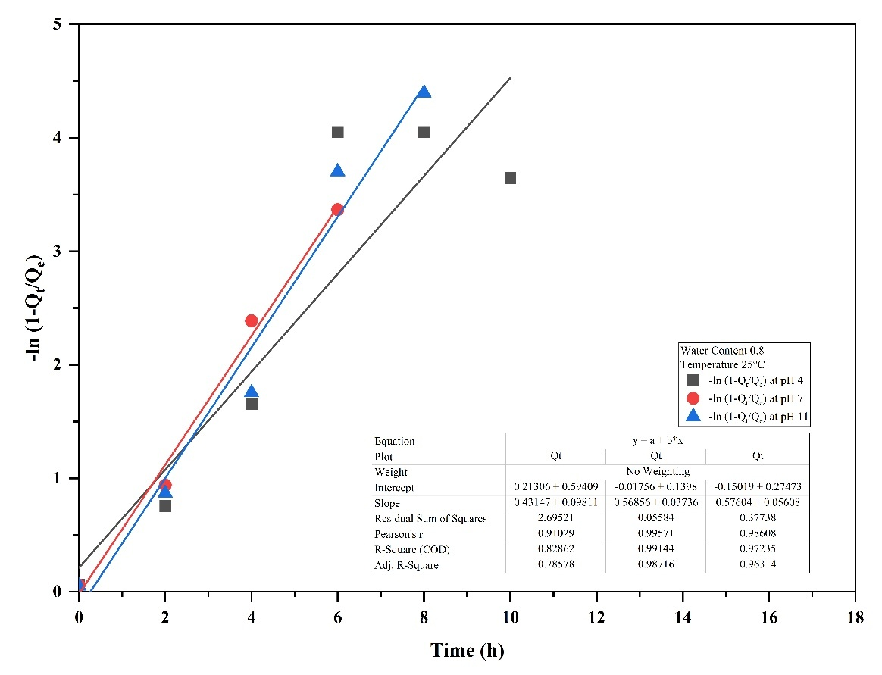

Fig. S38: LFD adsorption kinetics of Cr in sandy soil at pH 4, 7, and 11 under 25°C and WC 0.8

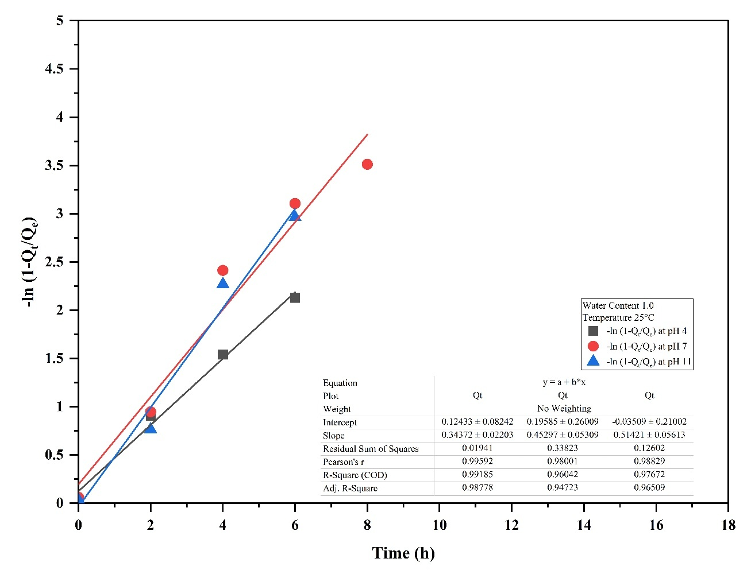

Fig. S39: LFD adsorption kinetics of Cr in sandy soil at pH 4, 7, and 11 under 25°C and WC 1.0

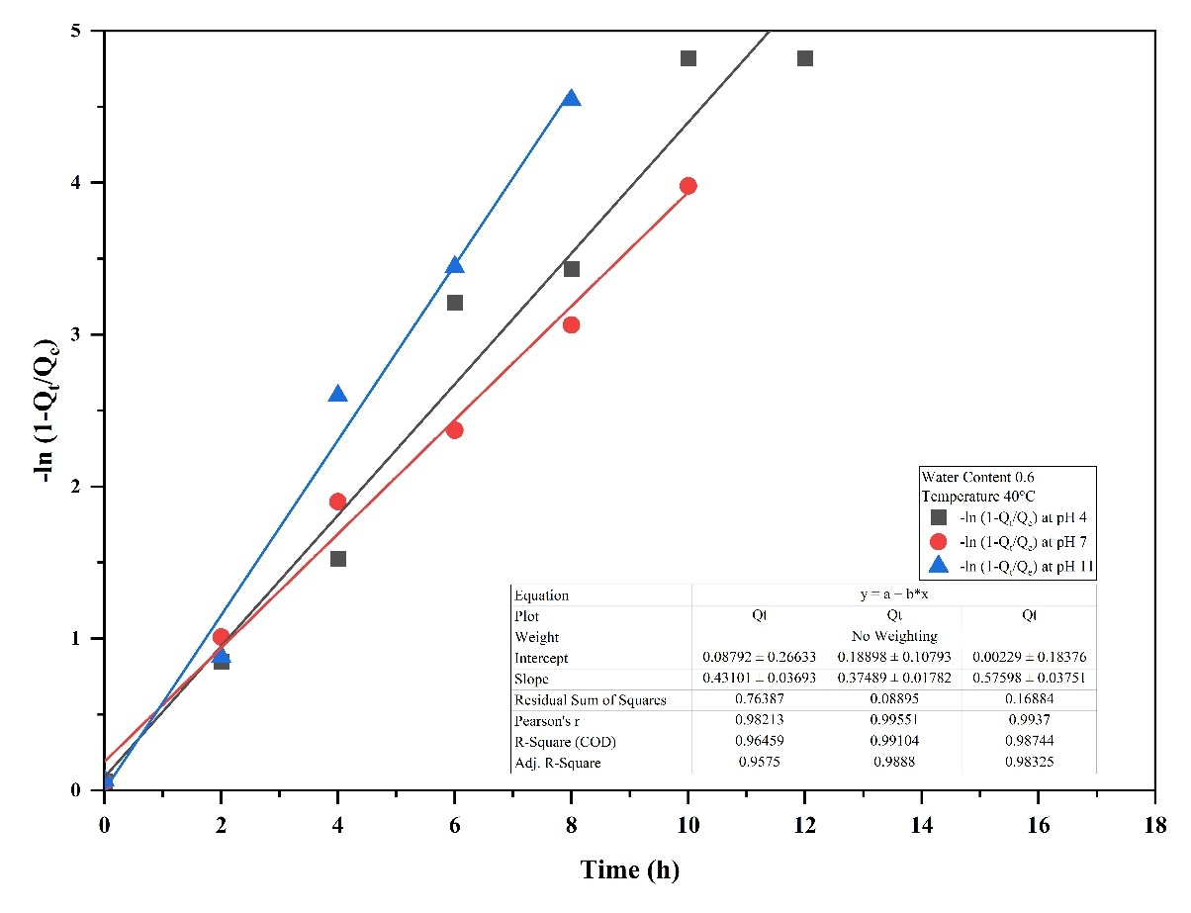

Fig. S40: LFD adsorption kinetics of Cr in sandy soil at pH 4, 7, and 11 under 40°C and WC 0.6

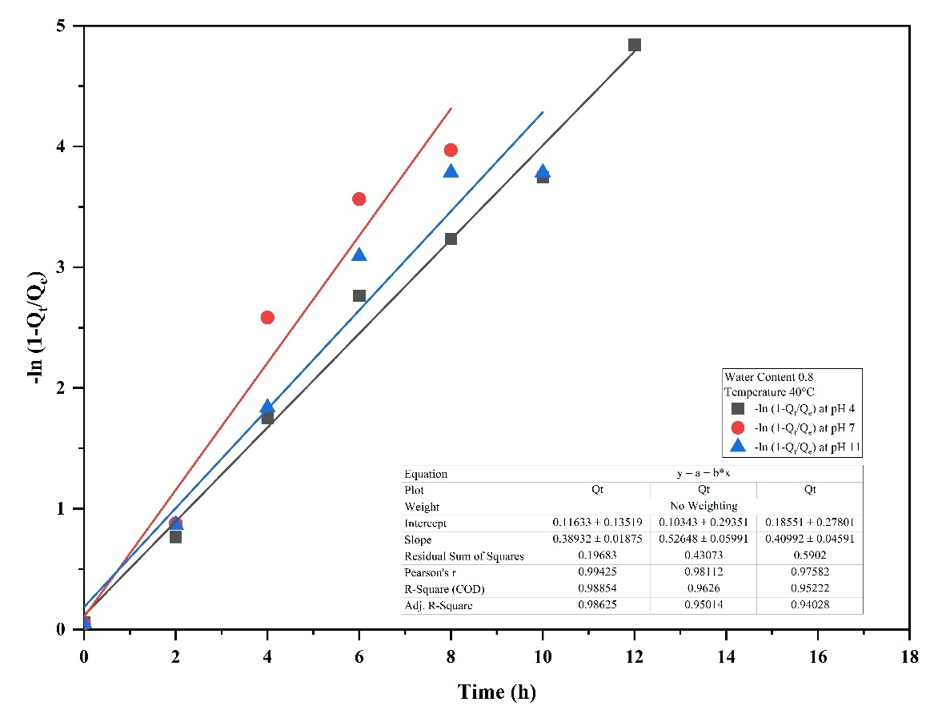

Fig. S41: LFD adsorption kinetics of Cr in sandy soil at pH 4, 7, and 11 under 40°C and WC 0.8

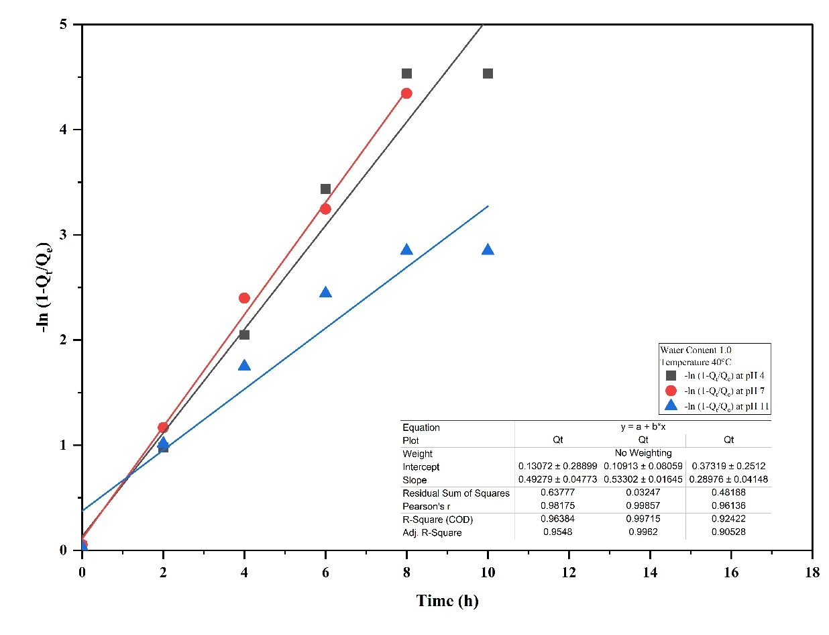

Fig. S42: LFD adsorption kinetics of Cr in sandy soil at pH 4, 7, and 11 under 40°C and WC 1.0

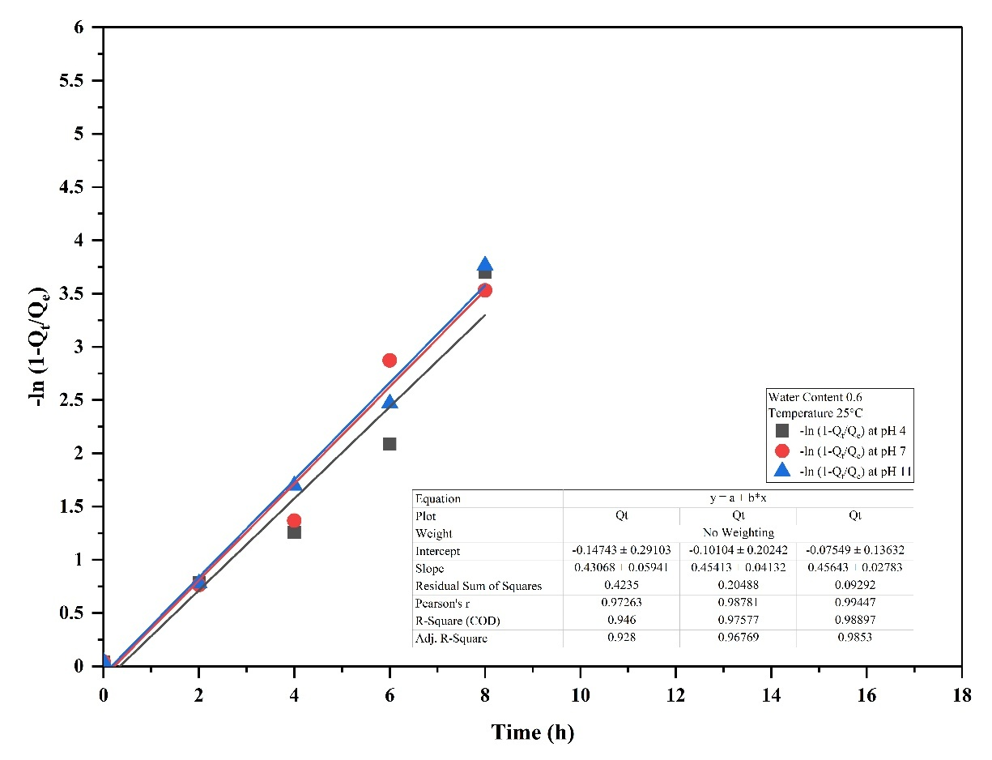

Fig. 43: LFD adsorption kinetics of Cr in Rania soil at pH 4, 7, and 11 under 25°C and WC 0.6

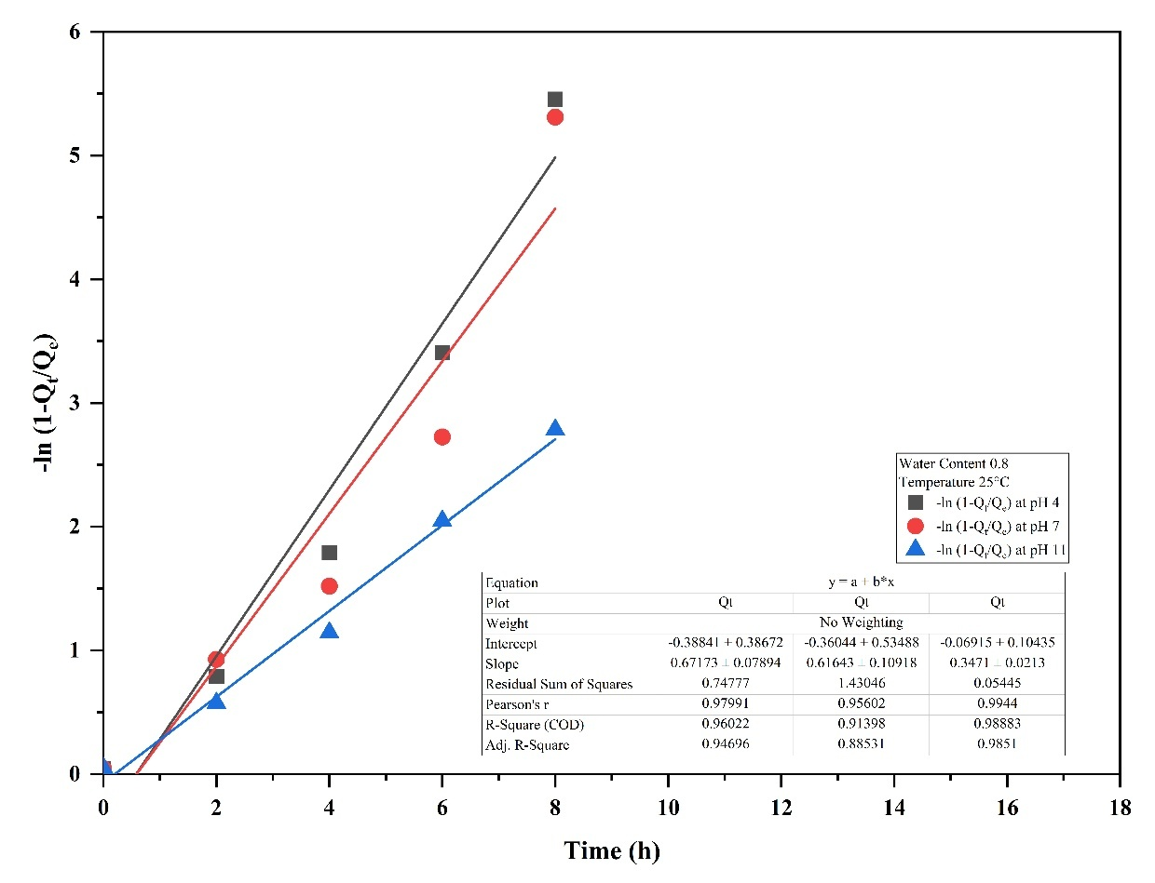

Fig. S44: LFD adsorption kinetics of Cr in Rania soil at pH 4, 7, and 11 under 25°C and WC 0.8

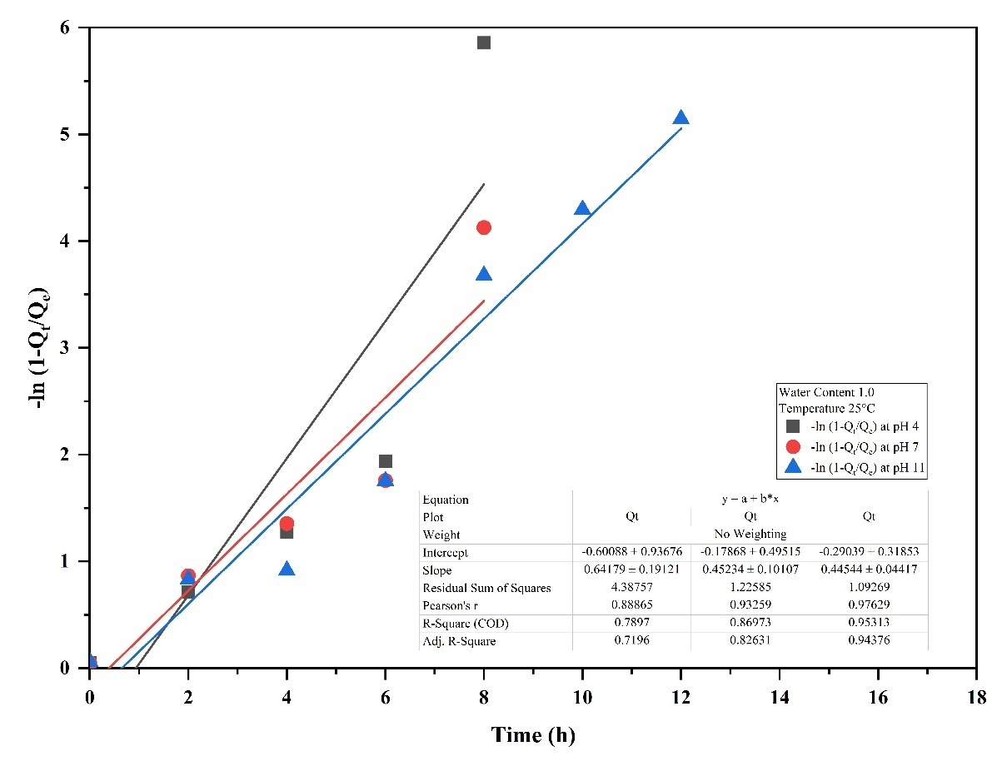

Fig. S45: LFD adsorption kinetics of Cr in Rania soil at pH 4, 7, and 11 under 25°C and WC 1.0

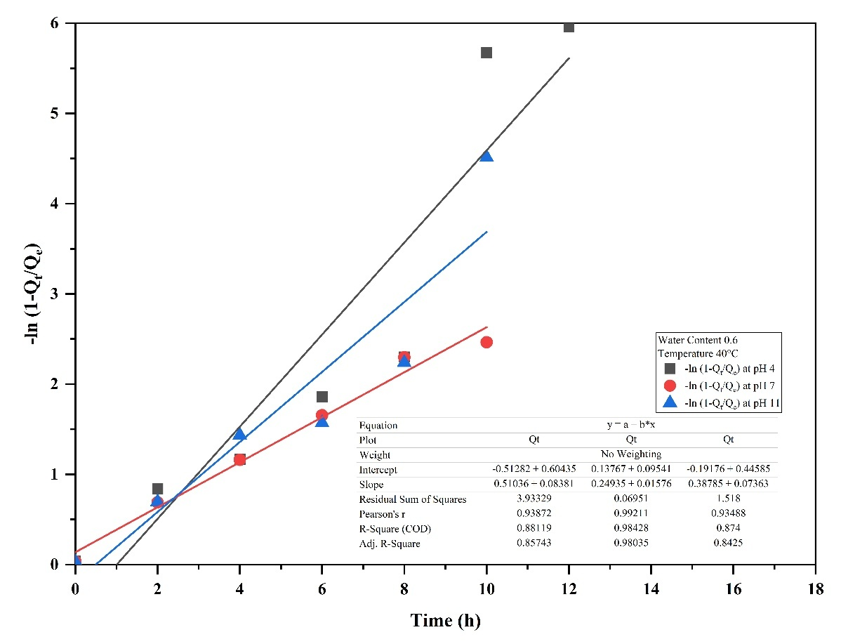

Fig. S46: LFD adsorption kinetics of Cr in Rania soil at pH 4, 7, and 11 under 40°C and WC 0.6

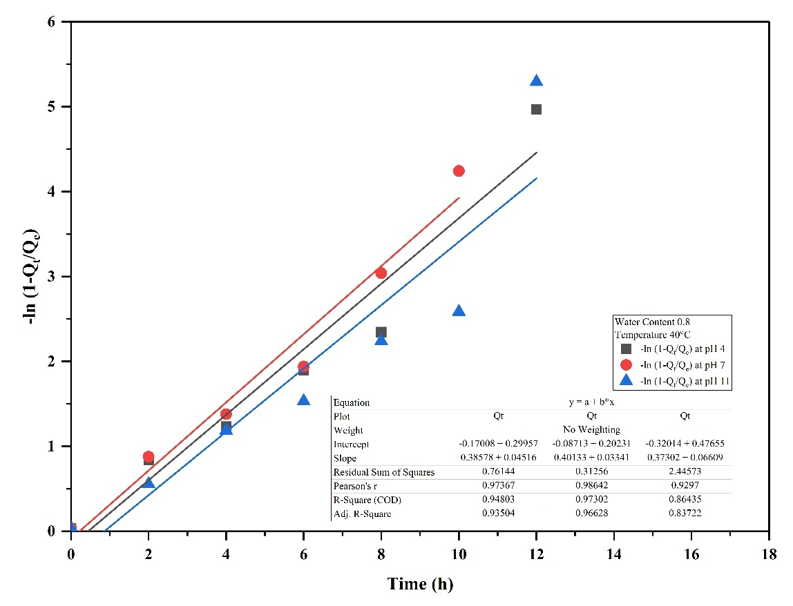

Fig. S47: LFD adsorption kinetics of Cr in Rania soil at pH 4, 7, and 11 under 40°C and WC 0.8

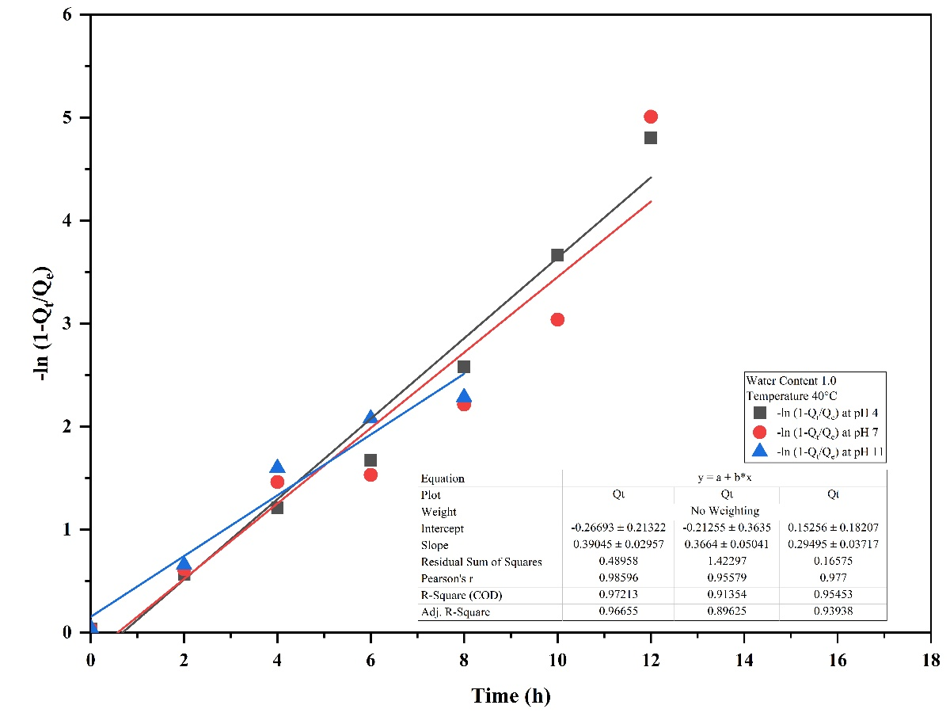

Fig. S48: LFD adsorption kinetics of Cr in Rania soil at pH 4, 7, and 11 under 40°C and WC 1.0

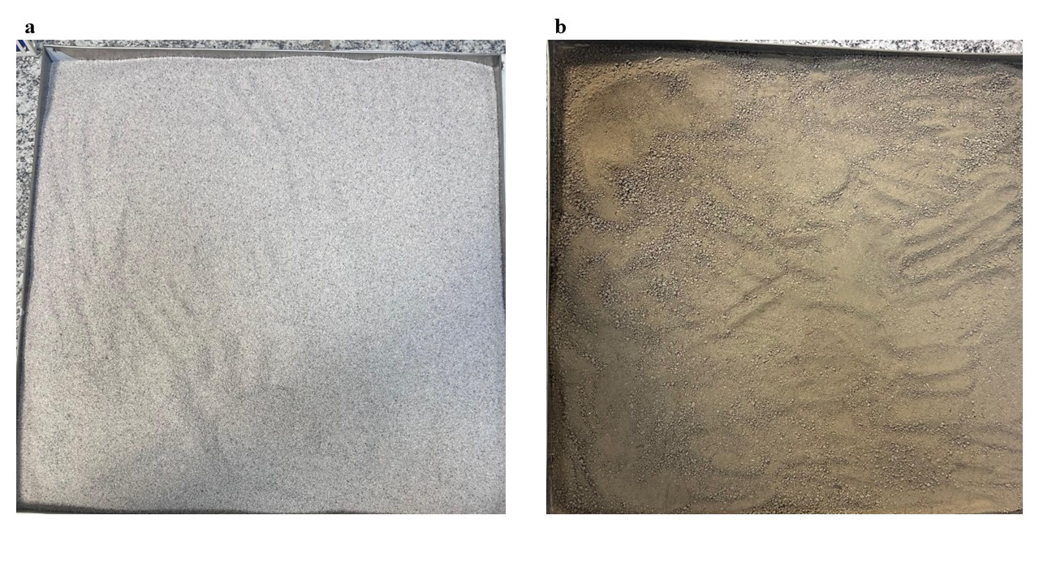

Fig. S49: IS standard 650-1991, Grade II, size 0.5-1.0 mm sand (a), and Silty loam soil sieve through 2 mm seive (Rania soil) collected from Rania-Khan Chandpur

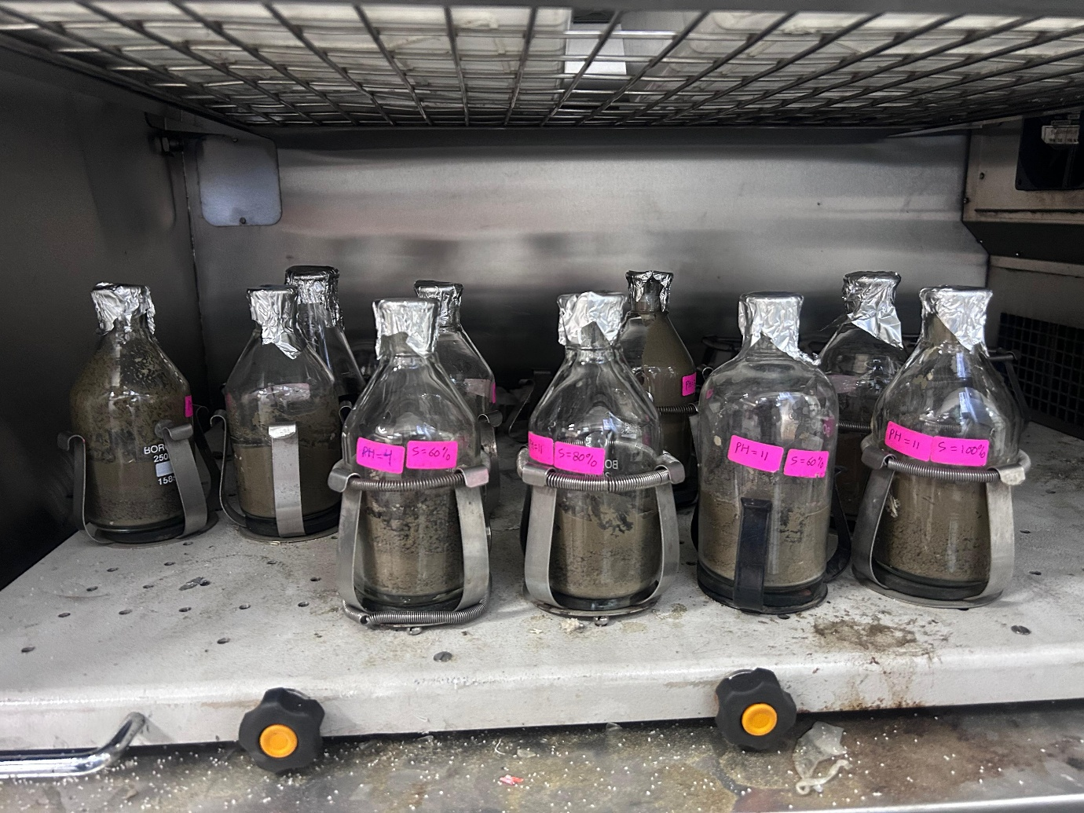

Fig S50: Experiment on Rania soil samples for kinetic adsorption at pH 4, 7, 11 and Water Content 60%, 80% and 100% at speed 180 rpm in triple deck shaker

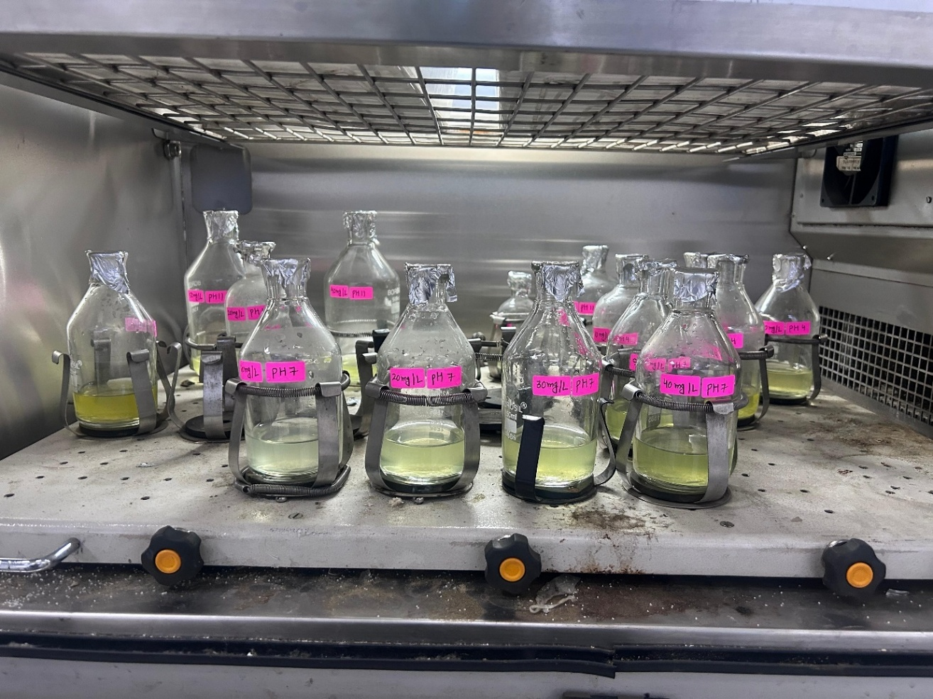

Fig S51: Experiment on Rania soil samples and sandy soil for isotherm adsorption at pH 4, 7, 11 and Cr concentration 10 mg L-1, 20 mg L-1, 30 mg L-1, 40 mg L-1 and 50 mg L-1 at speed 180 rpm in triple deck shaker